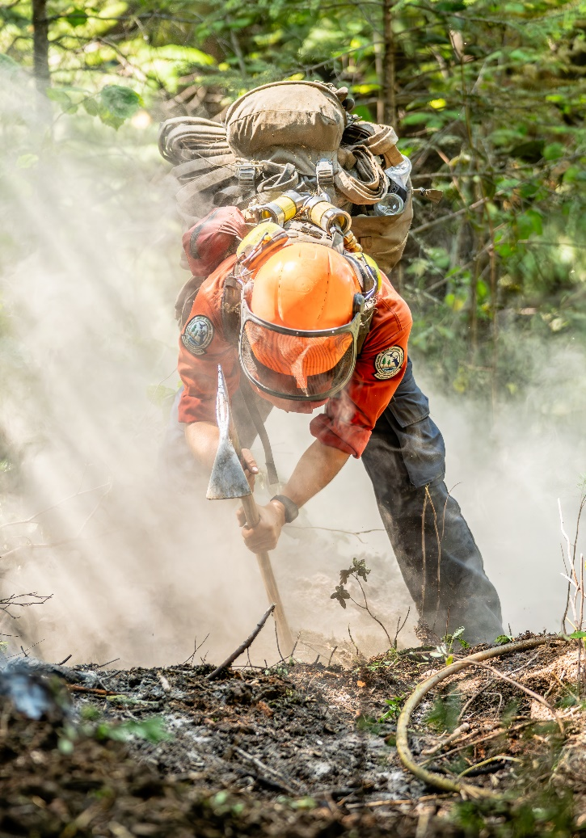
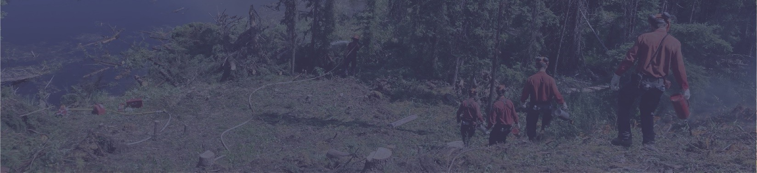


 Don’t miss the deadline!
Applications to become a wildfire fighter with BCWS open October 1st. The deadline for applications is Jan. 31, 2026.

All application packages must be received by 11:59 p.m. PST on the day of the application deadline.

Fill out our application form!
Applications must be completed and submitted online. The online application consists of a questionnaire with space for the applicant to paste a copy of their cover letter and resume. More information on the application package and firefighting with the BC Wildfire Service can be found here.

How to apply
Firefighting is the perfect career for a physically fit, motivated, team-oriented individual!

The BC Wildfire Service (BCWS) employs over 1,000 wildfire fighters each year. In order to become a wildfire fighter with BCWS, applicants must show motivation, have a relevant skill set, complete the WFX-FIT fitness tests, and attend the BCWS New Recruit Boot Camp

The majority of fire crews begin work in late April or early May and work until the end of October. Some crews remain working into November depending on fire conditions, activity, and project work.

BCWS fire crews usually work regular hours during the hottest part of the day, from 8 a.m. to 4:30 p.m., when fires are most likely to start. The normal work shift is eight hours per day and 40 hours per week, unless deployed to an incident. A fire fighter is guaranteed a 5-to-8-month work term depending on location of employment and fire activity.
What is it like to work as a fire crew member?

Wildfire Careers
Fire Crew Member

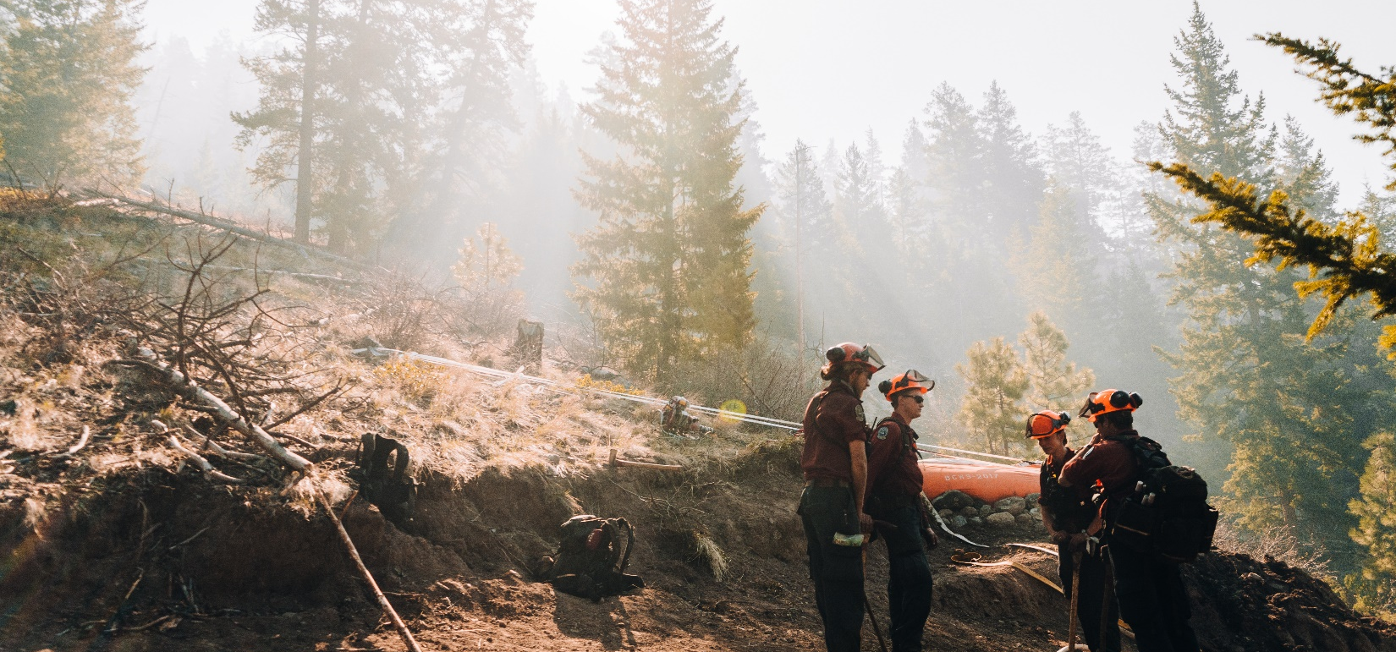

Common BC Class 5 Driver’s License Equivalents
AB | SK | MB | ON | QC | YT | NWT | AUS | EU | USA
Class 5 | Class 5 | Class 5 | Class G | Class 5 | Class 5 | Class 5 | Australian  Class C | International Driver’s  License | State  Dependent

 First aid requirements

All applicants must possess a first aid certificate recognized by WorkSafe BC or be enrolled in a recognized first aid course at the time of application. The minimum requirement is an acceptable Occupational First Aid Level 2 certificate with a transportation endorsement (or proof of enrollment), or an acceptable Occupational First Aid Level 3 certificate. First aid certificates must be valid until Oct. 31 of the fire season for which the applicant has applied. You will be asked at the interview to provide an acceptable first aid certificate, or proof of enrollment in a recognized first aid course. Information on equivalencies can be found here. Applications without appropriate first aid documentation will not be considered.
Initial Attack Weight Requirements
Initial attack and Parattack crews have weight requirements to align with the maximum allowable hover exit weights defined by the Canadian Aviation Regulations.
Rapattack has a different, lower weight requirement to align with set safety standards for rappelling from helicopters.

IA and Parattack ≤ 220 lbs
Rapattack ≤ 175 lbs
Driver’s License
A valid Canadian driver’s license (BC Class 5 or better) is required for all BCWS crews. Equivalent out of province, or out of country licenses are also accepted.
Class 7N may also be considered.
Requirements
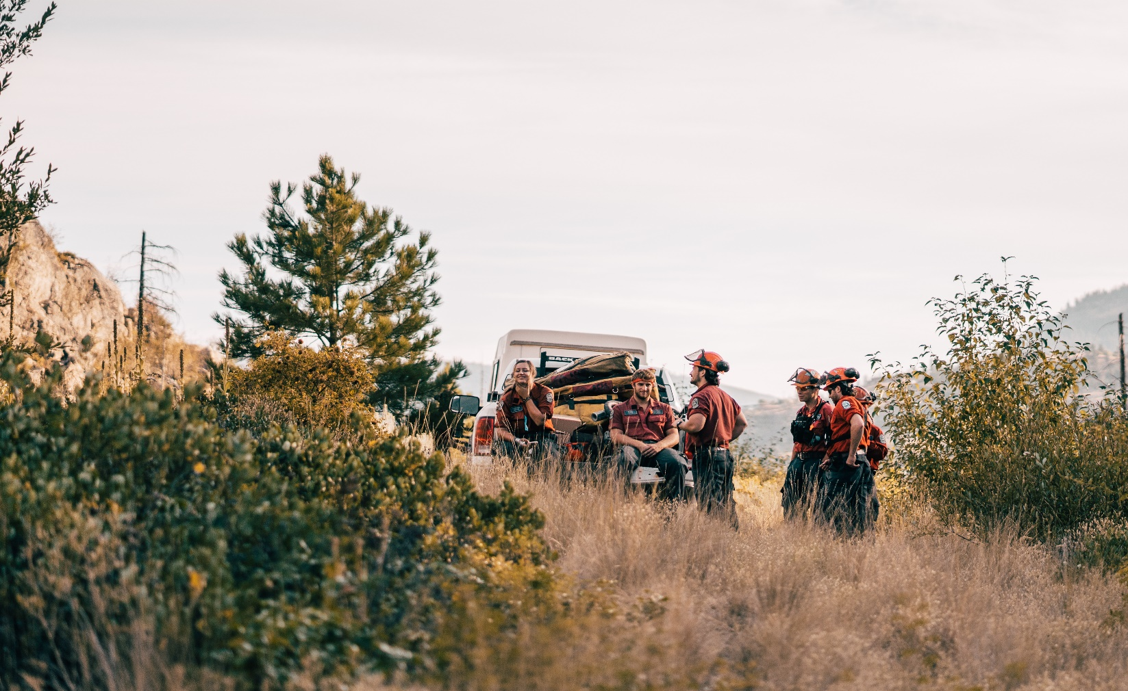
Applicants don’t have to meet all the preferred qualifications, but it is important to clearly identify which are met. Generally, an applicant is required to show strong examples in two or three of the preferred qualifications to be considered for an interview. The following are preferred qualifications (not in order of importance):
- Previous experience on a BCWS fire crew
  - include dates, location and supervisor
- Previous wildland fire fighting experience with a government agency
  - include dates and locations
- Previous contract crew wildland fire fighting experience
  - include company names, dates, and number of days deployed
- Forestry work experience
  - e.g. logging, planting, fall and burn, silviculture surveys, layout, etc.
  - include company names, dates, and locations
- Other resource-based work and experience
  - e.g. oil and gas work, mining, farming
  - include company names, locations, dates, and nature of work
- Mechanical aptitude or trades experience
  - e.g. experience or training with small engine repair
- Junior Fire Crew training or employment
  - Include dates and locations
- Post-secondary forestry or resource management education (in progress or completed), including university forestry program, diploma programs, and other resource management education recognized by the Association of BC Forest Professionals (ABCFP). e.g. “completed NVIT Environmental Resources Technology Diploma”
- Faller Certification
  - BC Forest Safety Council or Energy Safety Canada
- Volunteer Fire Department experience
  - Include fire department names, dates, locations, and details on experience with wildfires
- High level of fitness or sports achievements
  - awards received for fitness or team sports
- Academic achievements, scholarships or awards
Preferred qualifications
The general timeline for the recruiting process is:

- October 1st – online applications open
- January 31st – application deadline
- Interviews will be held every month, the month after you apply. Example: if you apply in October, expect an interview in November.
- Invites to New Recruit Bootcamp (NRBC) will go out to ~50 applicants each month after interviews are concluded.
- Mid May – job offers are sent out after NRBC
The recruiting process can be quite lengthy, running from the application deadline in January, to a possible boot camp invitation in April, and a job offer by mid-May. BCWS makes every effort to keep candidates informed on their status during this time, by email and phone, but it is your responsibility to ensure that your contact information is current throughout the process. If an applicant is no longer being considered, BCWS will advise the applicant directly, as soon as possible.
Timeline
After NRBC, successful candidates will be offered a position on one of the fire crews in the province. A first- year fire fighter can expect to work until the end of October and may be offered an extension depending on fire activity.
At NRBC the following courses are taught:

- Wildfire Service Overview
- Fundamentals of Fire fighting
- Portable Pumps and Water Delivery Systems
- Burning Off and Backfiring
- Heavy Equipment
- Chainsaw Operations
- Wilderness Survival
- Human Factors
- Fireline Communications
- Helicopter Safety
- Fire Weather
- Incident Command System
- Safety and Wildfire Entrapment
- Navigation
New Recruit Boot Camp
Based on the number of crew member vacancies, top-scoring applicants from the interview and preliminary fitness assessments will be invited to attend New Recruit Bootcamp (NRBC). Typically, three week-long boot camps are held in Merritt, starting in mid-April. Between 150 and 200 candidates are invited to boot camp depending on the number of vacancies on BCWS fire crews across the province.
During NRBC candidates must meet the pre- employment fitness standard which consists of the nationally recognized WFX-FIT test. This test is a pass or fail test and unsuccessful candidates will not be allowed to continue with the NRBC. In order to take the test candidates must bring a completed Physician’s Release Form (see link at end of this document) and present it to the WFX-FIT test appraiser.

Is the online application the only way to apply?
Yes. All applications are received on behalf of BCWS by the BC Public Service Agency. The application process consists of creating a profile, filling out a questionnaire and uploading text versions of your cover letter and resume. To apply, please look for the link posted in mid-November. Paper or faxed copies will not be accepted.

Do I attend the interview and fitness assessment in person?
No. Based on the current COVID-19 situation in our province the BC Wildfire Service will be using a virtual interview format to ensure the health and safety of all participants. There will be no fitness assessment at the time of the interview, but you will still need to pass the WFX-FIT test before employment.

How do I know if my first aid ticket is accepted in BC?
The list of recognised first aid tickets can be found on the WorkSafe BC website.

What if I cannot find my first aid ticket on the WorkSafeBC site?
If your ticket is not listed, it is likely that your ticket is not recognised by WorkSafeBC. To be employed by BCWS you must have a valid first aid ticket and transportation endorsement (or Level 3 first aid) which are recognised by WorkSafeBC. BCWS cannot consider your employment without a valid first aid ticket. You will be asked to show proof of acceptable first aid certification or proof of enrollment in a recognised first aid course at the interview. You must successfully complete a recognised first aid course prior to boot camp.

How can I get feedback on my application or interview?
Due to the large volume of applications, we are unable to provide individual feedback for applications. You must clearly detail in your resume and cover letter any preferred qualifications you meet. The interview panel may be able to provide general feedback from your interview when it is conducted, but they will not be able to tell you how well you did in relation to other interviewees.

How can I update my contact information?
Please refer to the instructions on the application site to update your contact information.
How many applications do you receive and how many jobs are there?
On average BCWS receives 1,000-1,500 applications each year. The number of jobs changes from year to year, ranging from 100 for a slow year, to over 200 for a high-turnover year.

Do I get to choose where I want to work?
Recruitment and crew allocation is a provincial process and applicants should expect to be placed on a fire crew anywhere in the province when they apply. An applicant’s preferred work location is considered but there are often limited openings. Individuals can be asked to go to another location or crew type that may not be their preference.

Will accommodations be provided for me?
In most cases people are responsible for finding their own accommodations near their work locations. Local and returning staff and crew members may be able to assist you in finding accommodations. In a few locations, staff housing is provided as an option either at no fee or at a nominal cost. These locations are Alexis Creek (Unit Crew), Chetwynd (Initial Attack), Fort Nelson (Initial Attack) and Salmon Arm (Rapattack).

Frequently Asked Questions
Online application page
First Aid certificates recognized by WorkSafe BC
First Aid Jurisprudence Process for out of jurisdiction by WorkSafe BC
Education recognized by the ABCFP
BC Public Service Agency competencies for interviews
Type 1 WFX-FIT fitness test
Links and Resources

Please direct any questions to:

Shea Smith
BCWS.Recruiting@gov.bc.ca

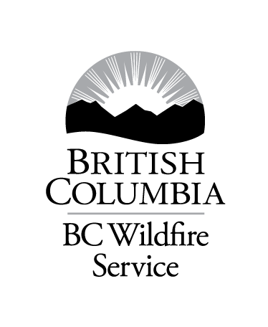
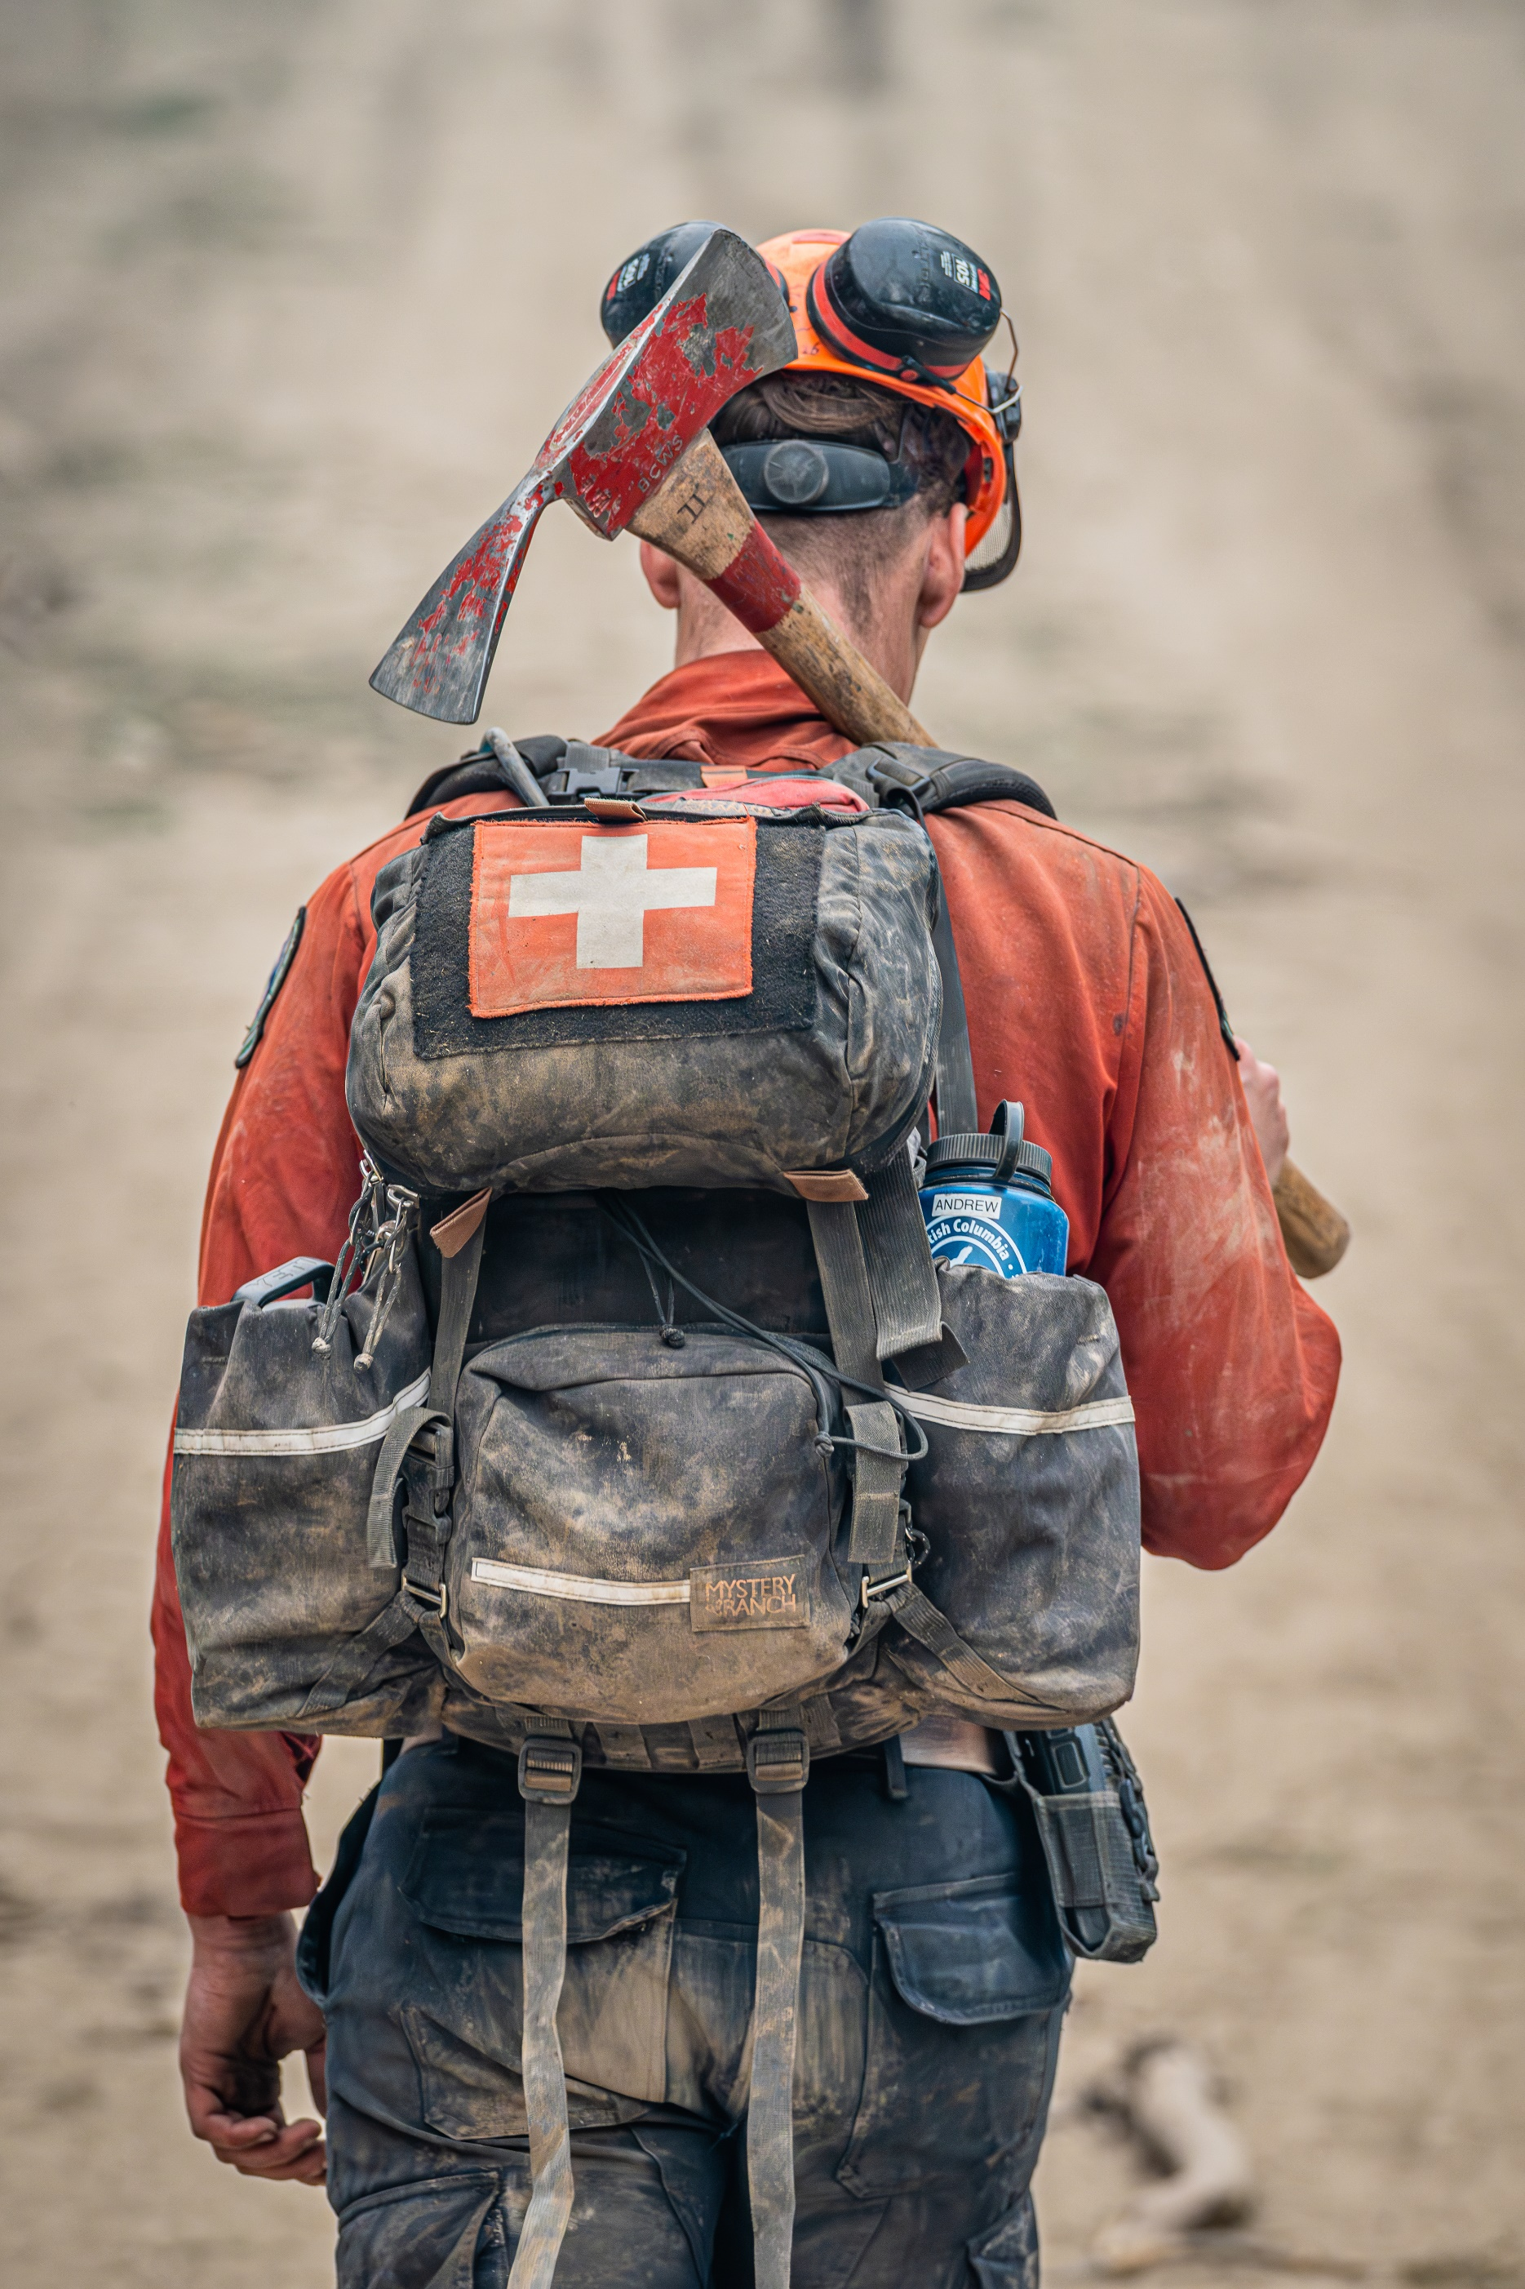
JOIN TODAY

