Post-Disaster Needs Assessment Plan
  - Template

Introduction i
Content

Template 1
Community operations sector 4
Economy sector 9
Housing sector 13
Environment sector 18
Health and mental health sector 24
Social recovery sector 30

Introduction

1.1 About this template
A post-disaster needs assessment (PDNA) creates a snapshot of the specific impacts and damages incurred by a community because of an emergency. The template is scalable and can be used following a small event (e.g. apartment building fire) or a large event (e.g. substantial flooding).
This PDNA template is a companion document to the Disaster Recovery Guide for Indigenous governing bodies and local authorities, which includes detailed information on recovery and how it relates to the other emergency management phases, options for recovery management models, guidance for common recovery activities and potential recovery funding sources.
The information gathered in a PDNA supports the completion of a Post-disaster recovery plan (Post-DRP), which identifies recovery principles, priorities and activities.
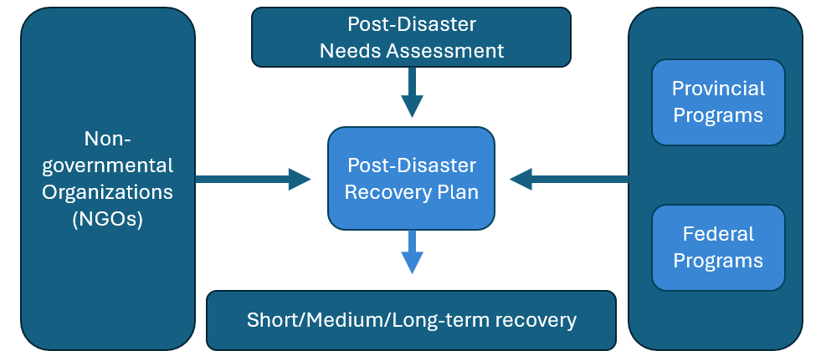
Figure 1: The sequence of how a PDNA and a Post-DRP work together

Communities are encouraged to consider the following best practices when completing a PDNA. The recommendations provided below may not apply to all communities in all situations. Each Indigenous governing body (IGB) or local authority is encouraged to use practices that work best for their community.

1.2 A sector-based recovery approach
This template organizes information by recovery sector to align with the Ministry of Emergency Management and Climate Readiness’ (EMCR) Provincial Disaster Recovery Framework (PDRF), which identifies provincial ministries that may offer recovery guidance and support. The six recovery sectors are:
- Community operations
- Economy
- Housing
- Environment
- Health and mental health
- Social
Grouping information by recovery sector promotes a more wholistic approach to recovery project planning and reduces the risk of inadvertently overlooking impacts.

1.3 PDNAs and the broader emergency management cycle
Under the Emergency and Disaster Management Act (the Act), communities are required to develop an emergency management plan (EMP) that addresses all four phases of emergency management: mitigation, preparedness, response and recovery. Some communities may refer to the recovery portion of their EMP as a pre-disaster recovery plan (Pre-DRP).
EMPs are to be:
- Prepared during the preparedness phase, before an emergency occurs
- Based on risk assessments
- Include information such as the measures necessary or advisable for the purposes of each phase and the roles, powers and duties of persons identified in the plan
After an emergency event, impact assessment tools such as rapid damage assessments (RDAs) and PDNAs are used to gather information and inform the development of the Post-DRP. The Post-DRP, in turn, forms the foundation for recovery project planning.
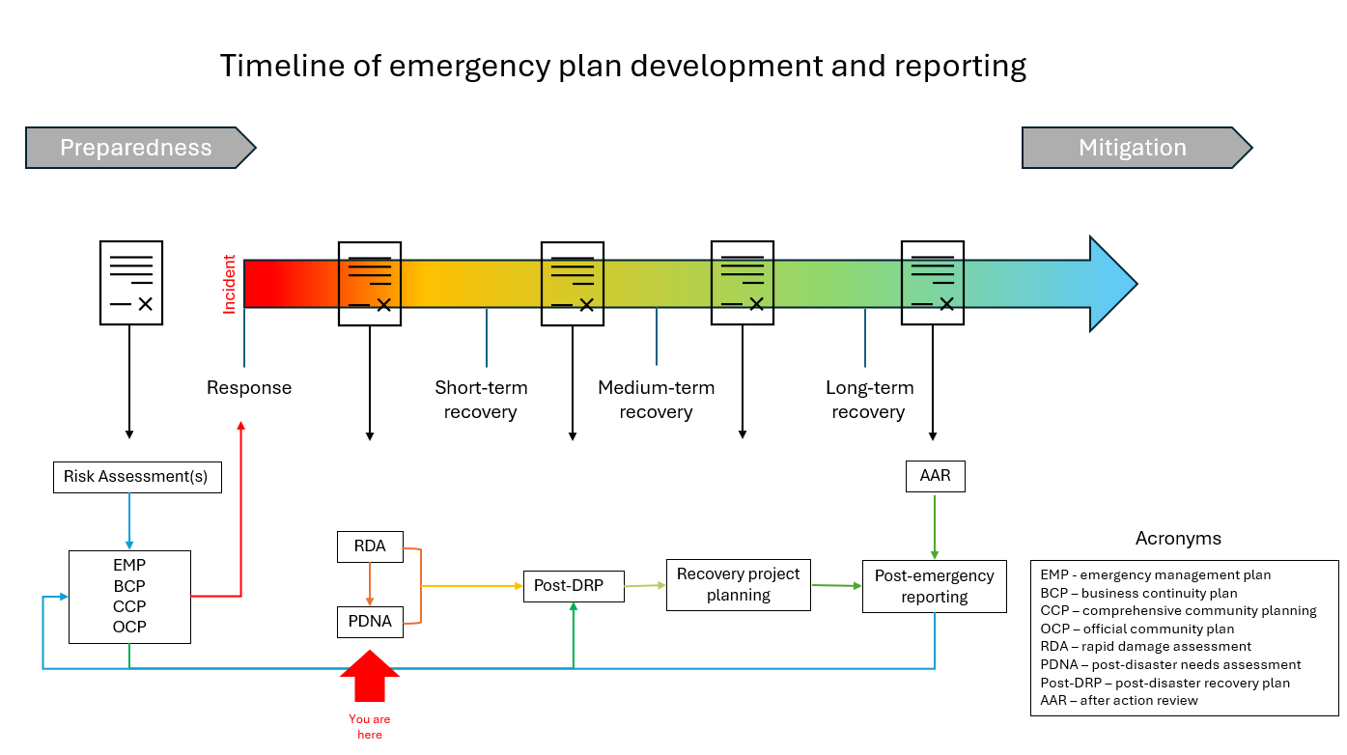
After action reviews (AARs) are typically done once a community has substantially completed their recovery through implementation of a Post-DRP. AARs identify best practices and lessons learned from the recent hazard season or emergency event, which may then be used to revise a community’s risk assessment, EMP, business continuity plan (BCP), official community plan (OCP) or comprehensive community plan (CCP), as applicable.
Figure 2: Timeline of emergency plan development and reporting

1.4 Suggested best practices when completing a PDNA
Communities are encouraged to consider the following best practices when completing a PDNA. The recommendations provided below are not prescriptive. Each IGB or local authority is encouraged to use practices that work best for their community.
- Assign a person to lead the PDNA process. Completing the assessment may require significant effort depending on the size and complexity of the event.
- Involve a larger participant group. The PDNA process does not have to be the sole responsibility of the IGB or local authority. Integrating non-governmental organizations (NGOs), critical infrastructure owner/operators, key businesses and community members can divide the work into manageable tasks. Specific recovery sector issues are often best understood by staff and residents already working in those areas, so including them can improve outcomes.
- Connect with vulnerable populations and those with intersectional disadvantages. Ensuring the information gathered is equitable can help reduce community vulnerability and increase long-term resilience. Building representation of vulnerable populations and those with intersectional disadvantages into a Community Advisory Committee (CAC), for example, is one way to achieve this goal.
- Review the template and prioritize the information that needs to be collected. One way to organize and prioritize information is to collect data based on:
- Information we already have
- Information we need
- Information we’d like to have if we have the capacity to collect it
- Information we don’t need
Prioritizing information in this way can make the data collection process more manageable and allow you to target specific collection efforts as capacity becomes available.
- Skip sections that aren’t necessary. The level of impact in each sector will vary depending on the event and the community. Some sectors may have minimal or no impact, while others may have been significantly impacted.
- Review and revise the PDNA regularly. The evaluation of emergency impacts is an ongoing process. Impacts, needs and resources identified immediately after an event are a snapshot in time and continued re-evaluation of impacts is recommended throughout the recovery process as information may become available weeks or even months after the event.

1.5 Assistance during the PDNA phase
The Ministry of Emergency Management and Climate Readiness can assist communities with coordination of recovery activities. EMCR’s Disaster Recovery Division staff can provide subject matter guidance on all stages of recovery and on the creation and implementation of PDNAs and Post-DRPs.
For further assistance, contact your EMCR regional office or provincial regional emergency operations centre (during an emergency event). You can also connect directly with Disaster Recovery Division staff by emailing PECC.Rec1@gov.bc.ca.

Template

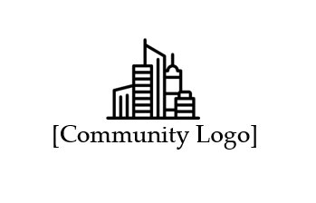
[Community Name]
[event year & name]
Post-Disaster Needs Assessment
Replace with community logo
[publishing date]
Replace with community logo or delete

Revision history
This is a living document. Unlike traditional documents, which are often considered static and final once created, a living document is meant to be dynamic and adaptable to changes over time. Track any additions or amendments in the amendment record below.
Version | Release date | Description of revision | Released/changed by
1.0
2.0
Table 1: Amendment Record

Instructions
All tables in this template can be expanded by adding or removing lines, or by copying and pasting segments of the table.

1.1 Population overview
This section should be filled out prior to starting the sectoral analysis (i.e., the subsequent sections). Understanding the demographics of a community’s population and whether they have sustained disproportionate impacts will enable a more targeted analysis of specific needs. Complete the following table using available data and update as required.
Total population: Click or tap here to enter text.
Total displaced: Click or tap here to enter text.
Total event related injuries: Click or tap here to enter text.
Total event related fatalities: Click or tap here to enter text.
Identifying disproportionate impacts to vulnerable populations
Young children: Children aged 0 to 4.
☐Yes ☐No ☐Unknown | Comments: Click or tap here to enter text.
School-aged children: Children aged 5 to 18.
☐Yes ☐No ☐Unknown | Comments: Click or tap here to enter text.
Post-secondary students: Attending post-secondary institutions.
☐Yes ☐No ☐Unknown | Comments: Click or tap here to enter text.
Seniors: Individuals aged 65 and older.
☐Yes ☐No ☐Unknown | Comments: Click or tap here to enter text.
First Nation individuals living off reserve: Registered (Indian Act status) First Nations individuals who reside outside of their affiliated First Nation community.
☐Yes ☐No ☐Unknown | Comments: Click or tap here to enter text.
Individuals lacking stable housing: Unhoused individuals or those at risk of becoming unhoused prior to the event. Homelessness can include hidden homelessness such as couch surfing or living at multiple locations.
☐Yes ☐No ☐Unknown | Comments: Click or tap here to enter text.
Individuals with English as a second language: Newcomers to Canada, members of culturally distinct communities and others who may face language barriers when accessing services or emergency information.
☐Yes ☐No ☐Unknown | Comments: Click or tap here to enter text.
Individuals with mobility challenges: Individuals that have physical difficulty moving around.
☐Yes ☐No ☐Unknown | Comments: Click or tap here to enter text.
Individuals with special medical needs: Individuals with physical or mental health needs that require specialized services or supports.
☐Yes ☐No ☐Unknown | Comments: Click or tap here to enter text.
Individuals with a low income: Individuals experiencing financial hardship and may have limited access to essential resources, services or supports.
☐Yes ☐No ☐Unknown | Comments: Click or tap here to enter text.
Temporary (transient) workers: Could include temporary foreign workers, agricultural workers or contractors for large building projects.
☐Yes ☐No ☐Unknown | Comments: Click or tap here to enter text.
Tourists: Estimated number of visitors in the community at the time of the event.
☐Yes ☐No ☐Unknown | Comments: Click or tap here to enter text.
Table 2. Identifying disproportionate impacts to vulnerable populations

Community operations sector

The community operations sector is responsible for ensuring the effective functioning of IGBs and local authorities, including identifying impacts to government operations, corporate services, and critical infrastructure.
Key considerations
- Impacts to continuity of government operations and corporate services.
- Status of critical infrastructure (utilities, communication networks, roads and bridges, trails and paths and transportation).

2.1 Impacts to government operations
Did your community lose historical accounting records, bylaws or band council resolutions or other records essential for government operations?
☐Yes ☐No ☐Unknown
Comments:
Click or tap here to enter text.

Did your community lose government tax records as a result of this event?
☐Yes ☐No ☐Unknown
Comments:
Click or tap here to enter text.

Have IGB or local authority staff or officials been unable to perform their duties due to this event? If yes, please comment on how long it might be before they will be able to resume their duties.
☐Yes ☐No ☐Unknown
Comments:
Click or tap here to enter text.

Were governance processes, such as permitting, board or council meetings, budget approvals or elections, impacted by this event?
☐Yes ☐No ☐Unknown

Comments:
Click or tap here to enter text.

2.2 Impacts to critical infrastructure and essential service delivery
Indicate the level of completeness of your community’s rapid damage assessment (RDA). This information is important, as the full extent of impacts—such as the number of restricted buildings—may not be fully understood until the assessments are complete.
Status of public sector RDAs:
☐ Completed ☐ In-progress ☐ Stalled ☐ Not started
Next, communities may wish to analyze impacts to specific infrastructure. The table below may be adjusted based on the community’s specific needs.
Impacts on critical infrastructure and essential service delivery
Emergency response facilities: E.g. community police offices and fire halls. Note: Emergency health services are considered under the health and mental health sector
Access and/or services impacted? | Click or tap here to enter text.
Interested parties: | Click or tap here to enter text.
Comments: | Click or tap here to enter text.
Public utilities: E.g. hydro lines, waste removal services, water and sewer services
Access and/or services impacted? | Click or tap here to enter text.
Interested parties: | Click or tap here to enter text.
Comments: | Click or tap here to enter text.
Public roads and bridges: Excludes privately owned roads
Access and/or services impacted? | Click or tap here to enter text.
Interested parties: | Click or tap here to enter text.
Comments: | Click or tap here to enter text.
Sidewalks, paths, and walkways: Excludes privately owned walkways
Access and/or services impacted? | Click or tap here to enter text.
Interested parties: | Click or tap here to enter text.
Comments: | Click or tap here to enter text.
Airports and airfields
Access and/or services impacted? | Click or tap here to enter text.
Interested parties: | Click or tap here to enter text.
Comments: | Click or tap here to enter text.
Harbours and ports
Access and/or services impacted? | Click or tap here to enter text.
Interested parties: | Click or tap here to enter text.
Comments: | Click or tap here to enter text.
Other public infrastructure
Access and/or services impacted? | Click or tap here to enter text.
Interested parties: | Click or tap here to enter text.
Comments: | Click or tap here to enter text.
Non-publicly owned critical infrastructure: Includes any critical infrastructure provided by other agencies and that provide a public service. E.g. cellular service
Access and/or services impacted? | Click or tap here to enter text.
Interested parties: | Click or tap here to enter text.
Comments: | Click or tap here to enter text.
Table 3: Impacts on critical infrastructure and essential service delivery

2.3 Impacts on primary access and critical supply routes
Identify impacts to primary access or critical supply routes. Provide details regarding accessibility impacts and estimated reopening timelines.
Route name | Restricted or closed? | Impacts | Estimated timeline to reopen
Table 4: Impacts on primary access and critical supply routes

2.4 Existing community plans
Provide a list of existing community plans that may inform emergency recovery planning, including any emergency management plans and business continuity plans.
Title | Date last revised | Plan implementation challenges
Table 5: Existing community plans

2.5 Recovery support agreements
List any recovery support agreements that the community has in place that could aid in recovery of the community operations sector (e.g., mutual aid agreements, services agreements, supplier arrangements).
Agreement Name | Date last revised | Comments
Table 6: Community operations recovery support agreements

2.6 Support organizations and agencies
List any organizations or agencies that could support recovery in the community operations sector. This could include government, non-government, non-profits, societies, faith-based groups and community-based groups.
Organization or agency | Area of support | Contact information
Table 7: Support organizations and agencies

Economy sector
The economy sector considers direct and indirect financial impacts including all of B.C.’s major economic sectors, Indigenous cultural livelihoods and infrastructure and environmental disruptions that could impact the overall economy.
Key considerations
- Direct and indirect impacts to the economy, including impacts to small, medium and large enterprise, tourism and cultural livelihood, agriculture and the broader economy.
- Impacts to critical businesses (i.e., pharmacies, grocery stores, daycares, hardware stores, etc.).

3.1 Economic impact assessment
Identify employers within key economic sectors of the community or region that are likely to be directly impacted for a significant period of time (e.g., tourism, retail, agriculture) and/or are indirectly impacted by the disruptions to key infrastructure (e.g., transportation networks, communications).
Business Category | Number of small businesses impacted  (<50 ppl) | Number of medium businesses impacted  (50 - 500 ppl) | Number of large businesses impacted  (500+ ppl) | Key economic sector?  (Yes/No) | Timeline to resume normal operations
Agriculture
Arts and cultural
Fisheries
Forestry/ mining
Government
Manufacturing
Micro businesses
Non-profits/co-ops
Professional services
Retail
Tech/web
Tourism
Table 8: Economic impact assessment

Based on the information in the above table, are additional actions needed to support workers in maintaining current employment and/or obtaining new employment?
☐Yes ☐No ☐Unknown
Comment:
Click or tap here to enter text.

3.2 Commercial vacancies and unemployment rates
Identify economic impacts to commercial vacancy rates and unemployment. These data points may be available through local real estate boards or firms and through the Province’s labour market statistics.
Vacancy and unemployment rates | Pre-event rate | Post-event rate
Commercial vacancy rate
Unemployment rate
Table 9: Commercial vacancies and unemployment rates

3.3 Market disruptions
Identify impacts hindering market activity and the exchange of goods and services (e.g., supply chain disruptions, increase in supply cost, demand exceeds supply).
Market disruption | Impact | Estimated length of disruption
Table 10: Market disruptions

3.4 Recovery support agreements
List any recovery support agreements the community has in place that could support recovery in the economic sector (e.g., mutual aid agreements, services agreements, supplier arrangements).
Agreement Name | Date last revised | Comments
Table 11: Economy recovery support agreements

3.5 Support organizations and agencies
List any organizations or agencies that have programs or services that could support recovery in the economy sector. Organizations and agencies may include government and non-government agencies, non-profits, societies, faith-based groups and community-based groups.
Organization or agency | Area of support | Contact information
Table 12: Support organizations and agencies

Housing sector

The housing sector considers impacts on the housing and accommodation of the impacted population through short-, medium- and long-term recovery. Once impacts are known and recovery planning begins, this sector also considers housing solutions in context of changing climate to ensure resilience for future events.
Key considerations
- Identifying short-, medium- and long-term housing and accommodation needs.

4.1 Residential property impacts
Provide the estimated number of impacted residential properties, based on rapid damage assessment (RDA) findings. The information gathered from these assessments helps to determine short-, medium- and long-term interim housing needs.
- Red carded units: unsafe for entry or use
- Yellow carded units: restricted entry or use
- Green carded units: no restrictions
Number of impacted residential properties
Single family housing: Detached properties and other non-multifamily dwellings
Total number of units assessed:
Number of each colour carded units: | Red: | Yellow: | Green:
Multifamily housing: Housing divided into two or more independent units. Count each unit as a singular residence
Total number of units assessed:
Number of each colour carded units: | Red: | Yellow: | Green:
Alternate accommodations: Mobile homes, tiny homes, house boats, RVs, watercraft, tents, etc.
Total number of units assessed:
Number of each colour carded units: | Red: | Yellow: | Green:
Table 13: Number of impacted residential properties

4.2 Interim housing needs
To determine interim housing needs and special considerations below, use the information contained in the above table (Table 13).
Interim housing needs | Number of units required for short-term support  (72 hours to 2 weeks) | Number of units required for medium-term support  (2 weeks to 3 months) | Number of units required for long-term support  (over 3 months)
No special considerations
Health/mobility requirements
Pet or livestock owners
Extended family units/ multigenerational housing
Table 14: Interim housing needs
Using Canadian Mortgage and Housing Corporation (CMHC) data or the local authority’s latest Housing Needs Report, what is the last-known residential vacancy rate (in %)?
Click or tap here to enter text.
Average rental rates
Studio
1-bedroom
2-bedroom
3-bedroom
Table 15: Average rental rates

4.3 Supportive housing needs
List any supportive housing needs within your community along with the estimated number of units required to meet those needs. Provide further details in the comment section.
Supportive housing needs | Number of units required for short-term support  (72 hours to 2 weeks) | Number of units required for medium-term support  (2 weeks to 3 months) | Number of units required for long-term support  (over 3 months)
Wet supportive housing
Comments: Click or tap here to enter text.
Dry supportive housing
Comments: Click or tap here to enter text.
Psycho-social supportive housing
Comments: Click or tap here to enter text.
Gender-specific supportive housing
Comments: Click or tap here to enter text.
Homeless shelters
Comments: Click or tap here to enter text.
Assisted living housing
Comments: Click or tap here to enter text.
Table 16: Supportive housing needs

4.4 Insurance
Provide the estimated number of residents who have either homeowners’ or tenants’ insurance and to what extent.
Insurance type | Complete coverage | Partial coverage | No coverage | Unknown
Homeowners insurance
Tenants insurance
Table 17: Residential insurance numbers

4.5 Primary residential heating sources
Identify and address any shortage or disruption to residential heating sources.
Heat source | Impacted  (Yes / No) | Number residences impacted | Impact details
Propane
Natural gas
Oil tank
Wood
Electrical
Table 18: Primary residential home heating sources

4.6 Additional questions
How many displaced residents have indicated they do not wish to return to the community prior to core services being re-established?
Click or tap here to enter text.

Does your community have a housing agency/authority or department? If yes, provide contact information:
Click or tap here to enter text.

Are there commercial accommodations (hotels, motels, short-term rentals, campgrounds, etc.) available that could be used as interim housing in or within a reasonable distance of the community? If yes, identify the accommodations and provide contact information.
Click or tap here to enter text.

4.7 Recovery support agreements
List any recovery support agreements that the community has in place that could support recovery in the housing sector (e.g., mutual aid agreements, services agreements, supplier arrangements).
Agreement name | Date last revised | Comments
Table 19: Housing support agreements

4.8 Support organizations and agencies
List any organizations or agencies that have programs or services that could support recovery in the housing sector. Organizations and agencies may include government and non-government entities, non-profits, societies, faith-based groups and community-based groups.
Organization or agency | Area of support | Contact information
Table 20: Support organizations and agencies

Environment sector
The environment sector begins by identifying environmental impacts, then defines an environmental recovery endpoint and outlines the steps required to achieve it. This sector primarily focuses on land degradation and contamination, biodiversity and ecosystem impacts, geotechnical hazards, cultural land use, natural resource damage/loss, natural resources including air, land, water, minerals, energy, weather, marine ecosystems on and offshore, soil and flora/fauna biodiversity.
Key considerations
- Impacts to the environment.
- Impacts to natural resources that directly affect the local and regional economies (e.g., forestry, fisheries, and agriculture).
- Impacts to cultural resources and their direct link to physical, mental and spiritual well-being.

5.1 Assessing environmental contamination
Indicate if there is any evidence or concern about environmental contamination for the following natural resources. This could also refer to anticipated environmental impacts. Include any visible spills or contamination.
Natural resource | Environmental contamination?  (Yes / No / Unknown) | Event related?  (Yes / No / Unknown) | Location(s)
Air
Comments: Click or tap here to enter text.
Potable water
Comments: Click or tap here to enter text.
Untreated river or lake water
Comments: Click or tap here to enter text.
Soil
Comments: Click or tap here to enter text.
Protected natural area
Comments: Click or tap here to enter text.
Fish bearing watercourses
Comments: Click or tap here to enter text.
Identified or potential heritage sites
Comments: Click or tap here to enter text.
Traditional food hunting or harvesting areas
Comments: Click or tap here to enter text.
Table 21: Environmental contamination

5.2 Assessing environmental hazards
Indicate if there are any new or worsening environmental hazards because of this event. Include any relevant information.
Hazard | New hazard?  (Yes / No / Unknown) | Location(s)
Landslide
Comments: Click or tap here to enter text.
Land instability
Comments: Click or tap here to enter text.
In-stream debris
Comments: Click or tap here to enter text.
Sediment accumulation
Comments: Click or tap here to enter text.
Bank instability
Comments: Click or tap here to enter text.
Danger trees
Comments: Click or tap here to enter text.
Soil runoff
Comments: Click or tap here to enter text.
Table 22: Environmental hazards

5.3 Debris removal or management
For each type of debris, indicate the geographical spread within the environment and whether there is a plan for its removal or management.
Debris type | Volume of debris | Removal/management plan in place?  (Yes / No / Unknown) | Landfill capacity
Building materials
Livestock debris
Green waste
Appliances
Scrap metal
Sediment and mud
Hazardous waste
Table 23: Debris removal or management

Are there any foreseen gaps and/or challenges regarding debris removal in your community?
☐Yes ☐No ☐Unknown
Comments:
Click or tap here to enter text.

5.4 Environmental testing and assessments
Using the services of a qualified environmental professional, determine the type of environmental testing and assessments required and identify a qualified laboratory or environmental professional that could provide those services to the community.
Environmental testing
Test required: Click or tap here to enter text.
Reason for test: | Click or tap here to enter text.
Qualified lab or environmental professional: | Click or tap here to enter text.
Contact information: | Click or tap here to enter text.
Test required: Click or tap here to enter text.
Reason for test: | Click or tap here to enter text.
Qualified lab or environmental professional: | Click or tap here to enter text.
Contact information: | Click or tap here to enter text.
Test required: Click or tap here to enter text.
Reason for test: | Click or tap here to enter text.
Qualified lab or environmental professional: | Click or tap here to enter text.
Contact information: | Click or tap here to enter text.
Test required: Click or tap here to enter text.
Reason for test: | Click or tap here to enter text.
Qualified lab or environmental professional: | Click or tap here to enter text.
Contact information: | Click or tap here to enter text.
Table 24: Environmental testing and assessments

5.5 Recovery support agreements
List any recovery support agreements the community has in place that could support recovery in the environment sector (e.g., mutual aid agreements, services agreements, supplier arrangements).
Agreement name | Date last revised | Comments
Table 25: Environmental recovery support agreements

5.6 Support organizations and agencies
List any organizations or agencies that have programs or services that could support recovery in the environmental sector. Organizations and agencies may include government and non-government entities, non-profits, societies, faith-based groups and community-based groups.
Organization or agency | Area of support | Contact information
Table 26: Support organizations and agencies

Health and mental health sector
The health and mental health sector considers impacts on the physical, mental, spiritual, cultural and social well-being of the population, with special attention to frontline workers and vulnerable populations. Once the impacts are known, further recovery planning can help to mitigate long-term impacts to well-being.
Key considerations
- Identification of key services and supports that contribute to physical, mental and spiritual well-being with special attention to frontline workers and vulnerable populations.

6.1 Health and mental health impacts to vulnerable populations
List the health and mental health impacts facing vulnerable populations and frontline staff within your community. Knowledge about impacts may come from several sources, including service providers, IGB or local authority staff or through surveys conducted by the Wellness and Unmet Needs Committee (see section 6.5 below). Include any relevant details in the comments column.
Vulnerable population(s) | Health and mental health impact(s) | Estimated number impacted | Comments
Children and youth
Seniors/First Nation Elders
LGBTQ2S+
Frontline staff
First responders
Those with complex medical needs
Those with complex mental health needs
Those with substance use disorders
Those who are unhoused or precariously housed
Those with English as a second language
Temporary (transient) workers
Table 27: Population vulnerabilities

6.2 Healthcare service impacts
Indicate impacts to healthcare services, including impacts to accessibility.
Service | Impacts to service availability?  (Yes/No/ Unknown) | Impacts to service accessibility?  (Yes/No/ Unknown) | Details
Emergency health services, ambulance and patient transfer
Coroner services
Hospital services
Primary care
(e.g., walk-ins or family doctors)
Urgent care
Continuing care
Specialized care
Home care
Pharmacies
Table 28: Healthcare and healthcare service impacts

6.3 Other health and mental health impacts
Describe any other impacts on the physical, mental, spiritual and social well-being of community members that have not been captured elsewhere in this sector.
Impact | Estimated number of people impacted | Comments
Table 29: Other health and mental health impacts

6.4 Mental health and wellness resources
List any mental health and wellness resources available to impacted individuals. This table can be used to identify any gaps in support and can be used for public information purposes.
Mental health and wellness resources
Disaster psychosocial first aid
Provider: | Click or tap here to enter text.
Contact information: | Click or tap here to enter text.
Support details: | Click or tap here to enter text.
Skills for psychological recovery
Provider: | Click or tap here to enter text.
Contact information: | Click or tap here to enter text.
Support details: | Click or tap here to enter text.
Crisis support
Provider: | Click or tap here to enter text.
Contact information: | Click or tap here to enter text.
Support details: | Click or tap here to enter text.
Counselling services
Provider: | Click or tap here to enter text.
Contact information: | Click or tap here to enter text.
Support details: | Click or tap here to enter text.
Services in other languages/cross-cultural wellness supports
Provider: | Click or tap here to enter text.
Contact information: | Click or tap here to enter text.
Support details: | Click or tap here to enter text.
Table 30: Mental health and wellness supports or services

6.5 Standing up a Wellness and Unmet Needs Committee
The Wellness and Unmet Needs Committee assists residents in recovering from the impacts of an emergency by evaluating unmet needs, identifying resources for meeting priority needs and recommending the allocation of limited resources. List any mental health and wellness service providers that may be contacted to participate as committee members. This could include public, private and non-profit organizations that have trained professionals available that can provide support.
Provider | Service(s) provided | Contact information
Table 31: Wellness and Unmet Needs Committee

6.6 Impacts to cultural or spiritual wellbeing
List any impacts to cultural or spiritual well-being. Some examples of cultural or spiritual considerations are culturally safe practices for all distinct cultures, cultural identity, resumption of religious practices and ceremonies and access to spiritual leaders. Include any loss to significant cultural items, sacred sites and/or ceremonial practices.
Cultural or spiritual well-being impact | Short description | Estimated timeline for recovery
Table 32: Impacts on cultures and traditions

6.7 Recovery support agreements
List any recovery support agreements the community has in place that could support recovery in the health and mental health sector (e.g., mutual aid agreements, services agreements, supplier arrangements).
Agreement Name | Date last revised | Implementation challenges
Table 33: Health and mental health support agreements

6.8 Support organizations and agencies
List any organizations or agencies that have programs or services that could support recovery in the health and mental health sector. Organizations and agencies may include government and non-government entities, non-profits, societies, faith-based groups and community-based groups.
Organization or agency | Area of support | Contact information
Table 34: Support organizations and agencies

Social recovery sector
The social recovery sector considers the impacts of emergencies on the core social supports people rely on, including childcare, education and other social services for vulnerable populations. Once impacts are known, the social sector seeks to provide an equitable approach for all impacted people, recognizing that those that are vulnerable or at an intersectional disadvantage, as defined in the Act, will require additional help accessing specific recovery supports.
Key considerations
- Identifying impacts to core social supports, including childcare, education and other social services for vulnerable populations.

7.1 Upcoming or recurring public events
List any upcoming or recurring community events that may be impacted by the emergency. This information helps assess whether upcoming events should proceed or be cancelled, the potential strain or disruption they may cause post-emergency and the social impacts on the community.
Event | Date(s) | Organizer
Table 35: Social service impacts

7.2 Social service impacts
List any impacts to social programs or services (e.g., libraries, recreational facilities and programs, food bank, Meals on Wheels, Boys & Girls Club) such as an increase in clientele, negative impacts to service capacity or a lack of staffing. If the support will be unavailable for an extended period, the community may wish to offer interim support services (if capacity and resourcing permits).
Program name | Short description | Estimated timeline for recovery
Table 36: Social service impacts

7.3 Educational impacts
List any impacts to educational facilities (e.g., schools, universities, dormitories or libraries), or educational programs (e.g., skills training, Strong Start or English language learning).
Educational impact | Short description | Estimated timeline for recovery
Table 37: Educational impacts

7.4 Childcare impacts
List any childcare services or supports that have been impacted, such as before and after school programs, daycares, day camps or overnight camps. Include a short description of the impact as well as a timeline for recovery.
Childcare impact | Short description | Estimated timeline for recovery
Table 38: Childcare impacts

7.5 Recovery support agreements
List any recovery support agreements the community has in place that could support recovery in the social recovery sector (e.g., mutual aid agreements, services agreements, supplier arrangements).
Agreement name | Date last revised | Comments
Table 39: Social recovery support agreements

7.6 Support organizations and agencies
List any organizations or agencies that have programs or services that could support social recovery. Organizations and agencies may include government and non-government entities, non-profits, societies, faith-based groups and community-based groups.
Organization or agency | Area of support | Contact information
Table 40: Support organizations and agencies





Wet supportive housing - supportive housing or shelters where tenants are not expected to abstain from using alcohol and other drugs, and where entering a rehabilitation program is not a requirement.
Psychosocial supportive housing - psychosocial support staff living within or nearby the facility.
Supportive housing for victims of domestic abuse, emergency shelters, transitional housing.
Assisted living housing for those with complex needs.

