Major Depressive Disorder in Adults: Diagnosis and Management
External Review Draft
- Scope
This guideline provides recommendations on the diagnosis and management of major depressive disorder (MDD) for non-pregnant adults ≥19 years old.
For guidance on depression during pregnancy and postpartum, consult guidelines from the Society of Obstetricians and Gynaecologists of Canada or the Canadian Network for Mood and Anxiety Treatments (CANMAT).
- Key Recommendations
- NEW: In adults with clinical suspicion of depression or salient risk factors, provide a targeted screening approach using a brief validated instrument (e.g., PHQ-2 followed by PHQ-9).
- If screening is positive, confirm diagnosis with DSM-5 TR criteria for MDD.
- Assess suicide risk in all patients with MDD using standardized questions or tools.
- Refer for urgent assessment when MDD presents with suicidal ideation, hallucinations, delusions, or other psychotic features.
- Rule out bipolar disorder as antidepressants may result in mood destabilization.
- Use psychotherapy and/or pharmacotherapy for treatment, as guided by symptom severity, patient preference and treatment availability. Continue psychotherapy as part of maintenance therapy.
- NEW: Administer a validated symptom rating scale (e.g., PHQ-9) every 2-4 weeks during acute treatment to monitor treatment response and guide treatment adjustments.
- NEW: Monitor for increased alcohol cravings or consumption if selective serotonin reuptake inhibitor (SSRI) is being used in someone with co-occurring depression and alcohol use disorder; and discontinue the SSRI if these effects emerge.
- NEW: When switching to another antidepressant, select another first-line drug based on side effect profiles. Evidence shows there is little difference in efficacy outcome between switching within the same or to a different medication class among first-line antidepressants.
- NEW: Initiate adjunctive pharmacotherapy following unsuccessful monotherapy trials of 2 or more antidepressants.
- NEW: Following symptom remission, continue antidepressants for a minimum of 6-12 months, or for at least 2 years in those with risk factors for recurrence.
- Taper antidepressants gradually over several weeks or months and consider using psychotherapy if available to reduce/mitigate discontinuation effects.
- Background
In Canada, mental illness leads to significant absenteeism, reduced quality of life, and in healthcare and productivity losses costing billions annually.¹ Depression causes substantial impairment in work, relationships, and daily functioning. In BC, the prevalence of depression in 2022/23 was approximately 7%.²
Depression is also associated with a higher risk of suicide.³ Of all people who died from suicide, about half suffered from MDD.^{4,5} More than 60% of individuals with MDD are unrecognized or misidentified in primary care settings.⁶
- Screening
We recommend against routine, universal screening for depression in all adults in primary care.^{5,7} In adults with clinical suspicion of depression or salient risk factors, provide a targeted screening approach using a brief validated instrument (e.g., PHQ-2 followed by PHQ-9). A list of common risk factors for MDD has been developed by CANMAT (See Table 1).
Start targeted screening by asking the following 2 questions based on the PHQ-2 questionnaire.

In the past two weeks:
- Have you lost interest or pleasure in things you usually like to do?
- Have you felt sad, low, down, depressed or hopeless?

Administer the PHQ-9 if the answer is ‘yes’ to either question.⁸ A score >10 in the PHQ-9 is generally considered a positive screen for an acute depressive episode. A score of 5-9 may be significant if there is high clinical suspicion or a history of previous depressive episodes. For other validated screening tools, see Practitioner Resources.
- Diagnosis
A positive screen should be followed by a comprehensive assessment to confirm a diagnosis of MDD, using the Diagnostic and Statistical Manual of Mental Disorders (DSM-5 TR) or International Classification of Diseases-11th Revision (ICD-11). See Figure 1 outlining an approach.
  - Signs and Symptoms
DSM-5 TR Criteria for MDD include having >5 depressive symptoms during a 2-week period, at least one of which must be depressed mood or loss of interest or pleasure in almost all activities, present for most of the day, nearly every day. For the list of diagnostic criteria see Table 2.
If the current depressive symptoms are directly attributable to the physiological effects of substance use or medications (Appendix A), then the diagnosis is substance/medication-induced depressive disorder.⁹
  - Suicide Risk
Suicide risk assessment should be a routine part of depression assessment, with a focus on understanding the basis for suicidal ideation/behavior and identifying personal strengths and protective factors for safety planning.
- Ask about suicidal ideation and behavior. If concerned regarding the patient's suicide risk, the Columbia-Suicide Severity Rating Scale (C-SSRS) is a standardized tool that can be helpful to further stratify the patient’s risk.
- Develop a safety plan. See Stanley Brown Safety Plan as an example.
- Seek emergency psychiatric consultation if the patient has escalation in suicidal thoughts, or a current plan, especially in the context of prior suicide attempt(s).
- Ensure patient is aware of the suicide support line (dial 988 or 1-800-SUICIDE) and that other resources are available at the Crisis Center. This can be accessed by the patient while the patient is in the office.
- If involuntary admission is required, complete the form for First Medical Certificate (Form 4.1). When a Form 4.1 is completed outside of a designated facility, it is valid for up to 14 days from the date of medical assessment and authorizes apprehension, detainment and transportation to a designated facility. The guide created by Vancouver Coastal Health and Providence Healthcare Involuntary Admissions Support Team may be helpful for filling out Form 4.1.
  - Differential Diagnoses
Below are important psychiatric conditions to consider when making a diagnosis of MDD.
    - Bipolar Disorder
Routinely screen for past hypomanic or manic episodes to assess for bipolar disorder by using a screening questionnaire such as the Mood Disorders Questionnaire or a question such as:
“Has there ever been a time in your life where for several days you had so much energy that other people thought you were not your normal self, or so much energy that you didn’t need to sleep, or that caused you to be unusually irritable and angry?
Ruling out bipolar disorder is important, especially because antidepressant use in an individual with undiagnosed bipolar disorder has the potential to destabilize mood.
About 10-15% of individuals with MDD may present with mixed features defined as the presence of 3 or more hypomanic symptoms such as increased energy, elevated mood, racing thoughts alongside sadness and low energy. If mixed features are suspected, consultation with psychiatry is recommended. If bipolar disorder is ruled out and pharmacologic treatment is required prior to psychiatric consultation, initiate first-line antidepressants with caution and monitor closely for activation, agitation, or emerging hypomanic symptoms. Short-term use of as-needed anxiolytics or sleep medications may also be considered with appropriate monitoring.
    - Anxiety Disorder
Routinely screen for anxiety symptoms using a validated tool such as Generalized Anxiety Disorder-7 (GAD-7) scale in all MDD patients because 40–60% of individuals with MDD have a co-occurring anxiety disorder. In addition, up to 75% of major depressive episodes meet DSM-5 TR criteria for the anxious distress specifier, which is characterized by prominent feelings of tension, restlessness, and excessive worry during the depressive episode. The presence of either a comorbid anxiety disorder or anxious distress is associated with a higher risk of suicide and poorer treatment response.
There is no strong evidence to support the preferential use of any specific antidepressant for individuals with comorbid anxiety or anxious distress. As such, all first-line antidepressants may be considered. However, clinical experience suggests that individuals with high levels of anxiety may be more sensitive to activating effects and other adverse reactions early in treatment.⁵ A more cautious approach to dosing and titration may therefore be helpful when initiating pharmacotherapy.
Cognitive behavioural therapy (CBT) is effective for both depressive and anxiety symptoms and should be considered, particularly when these conditions co-occur.

    - Substance Use Disorder
Routinely assess for substance use because depression symptoms are common in patients with substance use disorder.¹⁰ If the current depressive symptoms are directly attributable to the physiological effects of substance use, then the diagnosis is substance-induced depressive disorder.⁹ The critical differentiating factors between primary MDD and substance-induced depressive disorder include temporal relationship, symptom persistence after abstinence, and psychiatric history. See BC Guidelines for guidance on Alcohol Use Disorder (AUD) and Opioid Use Disorder.
Assessment and management of these concurrent conditions remain controversial and complex.^{11,12} Evaluate the severity and interaction of both conditions, assess suicide risk, and identify psychosocial stressors. Use clinical history and current risk factors, such as the extent of substance use, to guide which condition may need more immediate attention but avoid delaying care for either. Psychiatric consultation is recommended for these patients. While awaiting consultation, an individualized therapeutic approach with shared decision making is recommended.
In patients with mild depressive symptoms, treatment of AUD with first-line therapies (e.g., naloxone and acamprosate) should be prioritized and non-pharmacological therapies for mood disorders can be considered (see section 6.1). Treatment of the AUD itself may improve depressive symptoms. It should be noted that SSRIs should not be used for the primary treatment of AUD as this may lead to worsened outcomes such as increased alcohol cravings or consumption.¹¹
In contrast, in patients with moderate to severe depression or other psychiatric illnesses, first-line antidepressants (see section 6.2) are indicated, especially where there are safety (e.g., suicide) risks.^{5,12} Patients with a previously demonstrated response to antidepressants are more likely to benefit. Close monitoring for increased alcohol craving or consumption is warranted, as this has been reported with SSRIs and other serotonergic agents (e.g., trazadone) in some studies.^{11,12} It is also important to offer psychotherapy in patients with moderate to severe depression to enhance response rate and maintenance.⁵
    - Adjustment Disorder
In adjustment disorder, symptoms present within 3 months of an identifiable stressor and last less than 6 months (can be longer when the stressor is persistent).¹³ Importantly, the degree of distress is out of proportion to the severity or intensity of the stressor and results in significant impairment in important areas of functioning. Consider the context, social and cultural factors that might influence response.
If criteria for MDD are met, even in the presence of a clear precipitating stressor, the patient should be diagnosed with MDD and receive appropriate treatment for MDD.
- Management
The objectives of MDD treatment are to achieve symptomatic remission, recover full functioning, restore quality of life, and prevent recurrence.^{5,14} See Figure 2 for an overview of acute phase treatment and Figure 3 for an approach to assessing treatment response and making medication adjustments.
Use the PHQ-9 to help assess and monitor the severity of symptoms (Figure 4). It is also used for measuring treatment response and determining if a change in treatment (e.g., dose, antidepressant choice) is indicated.
While PHQ-9 scores are helpful in quantifying symptom severity, other factors such as degree of functional impairment and patient reported distress should be considered when determining severity for the purposes of treatment selection and monitoring.
  - Non-pharmacological Therapies
    - Health Behaviour Changes
Patient engagement and health-promoting behaviours are fundamental. For treatment of acute mild-moderate MDD, the following practices may have benefit as monotherapy or adjuncts to evidence-based pharmacotherapy and/or psychotherapy:
- Exercise: Low to moderate intensity exercise, 30-40 min at a time, 3-4 times a week for at least 9 weeks is recommended as a first-line monotherapy for mild MDD and a second-line adjunctive treatment for moderate severity MDD.⁵
- Light therapy: 10,000 lux white light for 30 min daily is recommended as first-line monotherapy for seasonal (winter) depression. It is also recommended as a second-line monotherapy for mild non-seasonal MDD, or as a second-line adjunctive therapy for moderate non-seasonal MDD.^{5,15,16}
- Sleep hygiene: Healthy sleep habits may be beneficial. CBT for insomnia has shown some benefits.¹⁷
    - Digital Health Technologies/Interventions (DHIs)
Guided internet-based CBT (iCBT), guided by a therapist or clinician, is recommended as a first-line monotherapy for mild depression, as a first-line adjunctive treatment for moderate depression, and to help prevent relapses.⁵ For example, BounceBack® is a free CBT-based, skill-building program designed to help adults and youths 13+ manage low mood, mild to moderate depression, anxiety, stress or worry. It is delivered online or over the phone with a coach.
    - Psychotherapy
Psychotherapy is recommended for all severities of MDD and in the maintenance phase to prevent relapse. It is similarly effective across most demographic factors, including sex, age, level of education, culture, and ethnicity.¹⁸
Monotherapy with first-line psychotherapies (Table 3), such as CBT, interpersonal psychotherapy (IPT) and behavioural activation,⁵ have been found to have comparable efficacy as monotherapy with antidepressants for acute treatment of all severities of MDD. CBT is more efficacious than medications alone in maintaining symptom response over 6-12 months.^{5,19} CBT is also recommended in patients with a recent history of a suicide attempt because it reduces suicide attempts by half in those who attempted suicide in the previous 6 months.⁵
The combination of psychotherapy and pharmacotherapy is more effective than either alone for treating acute symptoms and maintenance.^{5,19} Combined treatment should be considered for patients with chronic or severe episodes, psychiatric co-morbidity, or poor response to pharmacotherapy. For individuals with severe symptoms, a sequential approach may need to be taken, where pharmacotherapy is first established and psychotherapy is initiated after sufficient symptomatic improvement to allow patient engagement with therapy.
The strongest evidence suggests that most patients require 12 to 16 sessions. Twice-weekly sessions for CBT and IPT for depression show improved outcomes compared to once-weekly sessions. ^{5,20} All formats of CBT are efficacious. Inter-professional communication is important when treating shared patients.
Evidence-based structured psychotherapy should be considered and discussed with every patient. However, the choice between psychotherapy and/or pharmacotherapy is ultimately guided by patient preference and treatment availability/accessibility. Major barriers are accessibility and coverage. Mind Space is a non-profit organization offering MSP-funded mental health programs led by family doctors and psychiatrists. Psychotherapy services and other mental health supports are available for First Nations peoples through FNHA-Mental Health Support and Wellness.
For other population-specific types of psychosocial support for groups such as prenatal, postpartum, LGBTQ+, immigrants, see Practitioner Resources and Patient, Family and Caregiver Resources.
  - Pharmacological Therapies
    - Initial Choice of Antidepressants
Many first-line antidepressants have comparable efficacy (see Medication Table).^{5,21} Table 4 provides a high-level comparison of some of the considerations to help individualize therapy based on:
- Adverse effects: Select an antidepressant based on a patient’s tolerance of the adverse effects profile. Note that all antidepressants can cause temporary adverse effects, especially when starting or increasing the dose. These usually improve after 1-2 weeks. If adverse effects are severe, intolerable, or persist at a problematic level for more than 4 weeks, lower the dose or switch agents.
- Comorbidities: Consider if the antidepressant could exacerbate an existing comorbidity. For example, bupropion can lower the seizure threshold and is contraindicated in patients with seizure disorders and other conditions that increase seizure risk, such as history of eating disorder or recent discontinuation of regular alcohol/benzodiazepine use. Consider avoiding mirtazapine in someone with obesity or type 2 diabetes because mirtazapine may induce weight gain.
- Drug interactions: Use of some antidepressants concurrently with other medications may result in undesired effects, such as QT prolongation (e.g., citalopram) or seizure threshold reduction (e.g., bupropion). Use a drug interaction checker (e.g., Lexicomp(c))
- Cost and coverage: Out-of-pocket costs remain a significant barrier for many patients and often lead to cost-related nonadherence. Refer to Medication Table for details of approximate cost and PharmaCare coverage.
- Previous experience with antidepressants.
- Patient preferences: This may affect adherence.
Anxiety, agitation and suicide risk (especially in young adults) may increase transiently when pharmacological treatment is initiated.⁵ Review the safety plan (see example of a Safety Plan) and inform patients of the possibility of antidepressant discontinuation symptoms before starting pharmacotherapy. Monitor patients closely, arrange follow-up 1-2 weeks after initiation and adjust follow-up interval based on response. Seek emergency help if suicidal thoughts intensify.
Substance use is a negative prognostic factor for MDD. When prescribing SSRIs to individuals with concurrent mood and alcohol use disorders, monitor for increased alcohol cravings or consumption, and discontinue the SSRI if these effects emerge.¹¹ Treatments for reducing or abstaining from substance use should be initiated as these often relieve MDD symptoms.
Pharmacogenomic testing for antidepressant prescribing is increasingly available but is not currently publicly funded. A project on pharmacogenetic testing in BC is under way and is looking at testing criteria and care delivery models.
    - Promoting Adherence
Adherence to medication is critical for successful treatment. The following actions may be helpful:
- Remind patients to take medication as prescribed and not stop it independently, even if feeling better.
- Address patient concerns about antidepressants, e.g., clarify that antidepressants are not addictive.
- Set expectations. Initial improvement may appear within 1-2 weeks, but full effects typically take 4-8 weeks.
- Educate patients that mild side effects (use the HANDS mnemonic: Headache/dizziness, Anxiety/agitation, Nausea, Diarrhea/GI upset, Sleep disturbances) are common early on and usually resolve, but they should report symptoms that remain problematic beyond 2-4 weeks. Extra monitoring is warranted the month after starting or stopping of antidepressants to provide support and look for discontinuation syndrome, respectively (see below).
- Address sexual side effects explicitly. Ask about decreased libido, delayed or retrograde ejaculation, erectile dysfunction and/or difficulty achieving orgasm because patients may not volunteer this information. Treatment-related sexual dysfunction may persist throughout treatment; consider alternative treatments (e.g., bupropion).²²
- Treatment Response and Next Steps
  - Acute Phase Treatment
The goals of the acute phase, which typically lasts 8-16 weeks, are to achieve symptom remission and improve function. Remission is defined in DSM-5 TR as the absence or near absence of symptoms (e.g., PHQ-9 score 0-4) for at least 2 months. Response is defined as >50% reduction in symptom severity from baseline. Achieving symptom remission is crucial as it lowers the risk of relapse and residual depressive symptoms impair psychosocial functioning. Persistent depressive symptoms, even if mild, should be treated as they represent a major risk factor for recurrence.
Regular symptom monitoring during treatment initiation is critical to making informed treatment decisions. Lack of early improvement, defined as a <20% reduction in severity in the first 2-4 weeks, is a strong risk factor for ultimate non-response. If there is lack of early improvement in PHQ-9 scores in the first 4 weeks, a change to the treatment strategy – which may include optimizing dose, switching to another antidepressant or adding an adjunctive medication – is warranted.
If switching to another antidepressant due to being poorly tolerated or poor response, consider switching to another first-line antidepressant based on a favourable side effect profile for the individual patient, as opposed to the class of medication. Evidence indicates that there is little difference in efficacy outcome between switching within a medication class and switching to a different class.⁵ Expert opinion suggests that if two antidepressants from the same class have been used with poor response, then switch to another class.
Randomized Control trials (RCTs) and meta-analyses suggest that there is diminishing returns with successive antidepressant monotherapies, and there are generally higher response rates with adjunctive strategies.⁵ Therefore, consider adjunctive therapy rather than switching to another antidepressant if there have been at least 2 antidepressant monotherapy trials and the current antidepressant is well tolerated. Adjuncts may be considered even earlier, for example, if the first antidepressant trial is well tolerated and has resulted in >50% symptom improvement but not symptom remission. Addition of aripiprazole or brexpiprazole to an antidepressant are the 2 first-line adjunctive strategies per the CANMAT guidelines.⁵ Second-line adjunctive options include bupropion, mirtazapine, quetiapine XR, risperidone and lithium.²⁰
Figure 3 outlines steps in assessing treatment response and adjusting medications (see Table 4 and Medication Table).⁵ When feasible, introduce psychotherapy earlier rather than later, especially in complex presentations.
  - Maintenance Phase Treatment
The goals of the maintenance phase, which typically lasts 6-24 months, include maintaining symptomatic remission, restoration of premorbid functioning and quality of life, and recurrence prevention.
Psychotherapy appears to be more effective than antidepressants alone for preventing recurrence, as it helps patients acquire coping strategies and may confer longer-lasting benefits.⁵ Sustained response rates are seen with continued pharmacotherapy and psychotherapy; however, the risks vs benefits of long-term pharmacotherapy should be considered.
Continue antidepressants using the same acute phase treatment dose for a minimum of 6-12 months after achieving symptomatic remission.⁵ Patients with any of the following risk factors for relapse/recurrence should continue pharmacotherapy for >2 years:
- Persistent residual symptoms (e.g., anhedonia, sleep problems, cognitive dysfunction)
- History of adverse childhood experiences
- Presence of medical comorbidities
- Poor social support or persistent stressful life events
- History of recurrent and/or severe MDD episodes
- Patients with recurrent and severe MDD episodes should use sequential treatment (adding psychotherapy after stabilizing on medications) to prevent recurrence
Monitoring includes regular assessment of symptoms, adverse effects, and co-morbidities. Monitor weight, glucose and lipid profiles every 6 months when prescribing medications associated with weight gain, such as antipsychotics.
Encourage patient to return to usual employment (if appropriate) earlier than later. Employment supports wellbeing and mental health recovery by offering structure, purpose, and social benefits. There is an inverse relationship between the duration of an individual’s sick leave and the likelihood they will return to work. Being sick‐listed for 6 months or longer resulted in an 80% chance of remaining off work for 5 years. Combined work and clinical interventions can reduce sick leave and support a successful gradual return.^{23–25}
  - Stopping Antidepressants
Prior to stopping antidepressant therapy:
- Educate patient regarding early signs of relapse and risk of recurrence
- Educate regarding antidepressant discontinuation syndrome
- Consider continuing or initiating psychotherapy while tapering pharmacotherapy, especially in those with risk factors for recurrence
- Review safety plan
There is limited evidence guiding the optimal method for stopping antidepressants. Typically, reducing dose by 25-50% every 2-4 weeks is well tolerated. Slower tapering (e.g., decrease by 25% of the previous dose every 4-8 weeks) is also acceptable. Follow up should be arranged in 2-4 weeks after antidepressant discontinuation and then every 2-3 months for 6 months. Antidepressant discontinuation syndrome may occur in patients who have taken an antidepressant for 4 weeks or longer and may occur regardless of the tapering strategy used. Patients should be informed that:
- Common symptoms include Flu-like symptoms, Insomnia, Nausea, Imbalance, Sensory disturbances (“brain zapping”), Hyperarousal (mnemonic FINISH)
- Symptoms can begin within days of stopping and typically last 1-2 weeks, though some may persist longer
- Symptoms are transient and non-life-threatening but can be distressing
- Early signs of relapse may be similar to discontinuation; close monitoring is recommended
During tapering of medication, adjust dose based on symptoms. If withdrawal occurs, return to the last tolerated dose and taper more slowly. If symptoms remain intolerable at the lowest dose, consider switching to fluoxetine, which has a long half-life and is available in liquid form.
Abrupt discontinuation or rapid tapering over 1 to 2 months may be necessary or preferred when:
- The patient is pregnant (Society of Obstetricians and Gynaecologists of Canada)
- There are drug interactions or toxicity
- Treatment duration was short-term (4-8 weeks)
- The drug has a long half-life (e.g., fluoxetine)
Gradual tapering is preferred when:
- The patient has been on a high dose or long-term treatment
- The drug has a short half-life (e.g., paroxetine, venlafaxine)
- There is a history of withdrawal symptoms
- The patient prefers to self-adjust based on symptoms
  - Difficult-to-Treat Depression (DTD) vs Persistent Depressive Disorder (PDD)
DTD is used to describe persistent depression that has failed numerous standard treatments. Psychiatry consultation is recommended. While awaiting consultation, consider using adjunctive medications (see Medication Table) and continue using psychotherapy. Close collaboration with psychiatrists and other mental health specialists is required to support coordinated care. In some cases of DTD, prioritizing incremental improvements in quality of life and functioning may be more clinically useful than targeting full symptom remission.
PDD is characterized by experiencing persistent depressed mood and 2 accompanying MDD symptoms for >2 years. Some affected individuals will meet full criteria for a major depressive episode for more than two years. PDD is associated with lower remission rates and higher degree of long-term functional impairment than MDD. Management for PDD should employ the DTD framework.⁵
Therapies listed below for DTD are accessible only through a psychiatry consultation:
- Electroconvulsive Therapy (ECT): For severe or DTD involving suicidality, psychotic features, or catatonia, ECT is considered one of the most effective treatments. ECT demonstrates response rates of 65-75% in DTD and is often superior to pharmacological interventions.⁵ When administered with proper assessment and monitoring, ECT is safe and well-tolerated. ECT is available in inpatient and outpatient settings.
- Repetitive transcranial magnetic stimulation (rTMS): rTMS has the most evidence for efficacy following ECT. rTMS also does not require anaesthesia and has few cognitive side effects.⁵ However, currently, rTMS is not covered by MSP.
- Psilocybin: is currently an experimental treatment used primarily within clinical trials or, less commonly, through special access program in rare and special circumstances.²⁶ Micro-dosing with psilocybin is not supported by current evidence.²⁷
- Ketamine and its nasal spray form, esketamine: are newer adjunctive treatments for DTD used only by experienced clinicians and under strict eligibility criteria. These include failure of at least two antidepressants and one adjunctive treatment, absence of active psychosis and recent substance use disorder, and no contraindications such as unstable medical conditions or pregnancy.²⁸ Both forms must be administered under medical supervision. Common side effects include dissociation, hypertension, and agitation. There is potential for abuse and limited data on long-term safety.²⁹
  - Complementary and Alternative Medicine (CAM) Treatments
Always ask patients about CAM/OTC use. While acupuncture, L-methyl folate, St. John’s wort, saffron, lavender, roseroot have shown benefits in mild and moderate depression,⁵ evidence is weak and many (especially St. John’s wort) have significant drug interactions and so should be used with caution. To date, no CAM treatment has reached the level of evidence that would make it comparable to a first-line psychotherapy or pharmacotherapy for moderate to severe depression.³⁰
- Special Populations
  - Chronic Pain
Depression and chronic pain frequently coexist and chronic pain-induced depression is also prevalent.³¹ Patients with comorbid depression and chronic pain are less likely to derive functional benefits from antidepressants.³² Duloxetine is a first-line recommended antidepressant for individuals with MDD and certain comorbid pain disorders.³³
  - Frailty and Elderly
Age alone is not a reason for screening for depression, but those with frailty often have comorbidities or living circumstances that warrant screening. Pharmacotherapy for depression should be considered in light of comorbidities and polypharmacy. Older adults may take longer to respond, have increased risk of adverse events, drug-drug interactions, anticholinergic burden and falls risk. For geriatric guidelines refer to the 2021 Canadian Guidelines on Prevention, Assessment and Treatment of Depression in Older Adults. Consider routine monitoring of electrolytes in elderly patients on SSRIs/serotonin-norepinephrine reuptake inhibitors (SNRIs) due to increased risk of hyponatremia from syndrome of inappropriate antidiuretic hormone secretion.
  - Eating Disorders
The prevalence of MDD in those with anorexia nervosa is exceptionally high at a rate reaching 93.3%.³⁴ A bidirectional relationship exists between the two, with each condition potentially exacerbating the other. Studies suggest that weight restoration may positively impact mood states in some patients but most patients may need treatment modalities such as ECT, rTMS, and deep-brain stimulation.³⁵ Some medications (e.g., bupropion, fluoxetine, mirtazapine) may exacerbate weight changes or lead to increased risk of side effects. Bupropion is additionally contraindicated in those with history of anorexia or bulimia nervosa due to increased seizure risk.
- guideline development and Contributors
This guideline is an updated version of the BCGuideline: Major Depressive Disorder in Adults - Diagnosis and Management (2013). The recommendations are tailored to support primary care practice in BC and are based on recommendations from Canadian Network for Mood and Anxiety Treatments (CANMAT) Update on Clinical Guidelines for Management of Major Depressive Disorder in Adults (2023) and an updated literature review. In situations lacking rigorous evidence, expert and experience-informed clinical opinion is provided to support decision making and high-quality patient care. Contributors of this guideline are listed here [link when published]. For further details about the guideline development process, see BC Guidelines.
- Abbreviations
AD | adjustment disorder | DTD | difficult-to-treat depression
AUD | alcohol use disorder | ECT | electroconvulsive therapy
CANMAT | Canadian Network for Mood and Anxiety Treatments | iCBT | Internet-based CBT
CAM | complementary and alternative medicine | IPT | interpersonal psychotherapy
CBT | cognitive behavioural therapy | MDD | major depressive disorder
C-SSRS | Columbia-Suicide Severity Rating Scale | PHQ | Patient Health Questionnaire
DHI | digital health technologies/Interventions | rTMS | repetitive transcranial magnetic stimulation
- Practitioner Resources
- Related BC Guidelines:
  - High-Risk Drinking and Alcohol Use Disorder
  - Managing Patients with Pain in Primary Care
  - Opioid Use Disorder - Diagnosis and Management in Primary Care
  - Tobacco Use Disorder
  - Primary Care Approaches to Addressing the Impacts of Trauma and Adverse Childhood Experiences
- Canadian Network for Mood and Anxiety Treatments (CANMAT): Evidence-based guidelines for MDD
- Pathways: Depression Enhanced Care Pathway - Adult
- Depression Screening Tools:
  - PHQ-9
  - Center for Epidemiologic Studies Depression Scale (CES-D)
  - Quick Inventory of Depression-Self Report
  - Montgomery-Asberg Depression Rating Scale (MADRS)
- First Nations Health Authority offers culturally safe and trauma-informed cultural, emotional, and mental health services, including 24-hour crisis and help lines. See FNHA-Mental Health Support and Wellness and list of Mental Health and Wellness Support resources.
- Mind Space: MSP-funded mental health programs led by family doctors and psychiatrists.

- Patient, Family, and Caregiver Resources
- Antidepressant Skills Workbook: A self-care manual developed by Simon Fraser University, based on the experience of the authors and on scientific research about which strategies work best in managing depression.
- BC Partners for Mental Health and Addictions Information - provides Mental Disorders, Depression and Anxiety Disorders Toolkits.
- Bounce Back: A free skill-building program designed to help adults and youth 13+ manage low mood, mild to moderate depression, anxiety, stress or worry.
- Canadian Mental Health Association: telephone 1-800-555-8222, website: https://bc.cmha.ca/
- BC Mental Health Support Line - Call 310-6789 (no area code). It’s free, anonymous, confidential and available 24/7.
- 9-8-8 National Suicide Crisis Helpline/ Ligne d’aide en cas de crise de suicide. This phone line provides free access to 24/7 emotional, and crisis support in English or French.
- BC Suicide Prevention and Intervention Line - Call 1-800-SUICIDE. It stands for 1-800-784-2433. This phone line provides confidential support for people who are in crisis, are really upset or scared, or have thoughts of suicide or self-harm.
- CHOICE–D patient and family guide to depression treatment: developed by CANMAT and the Mood Disorders Association of Ontario to empower individuals to understand treatment options and to engage in conversations about treatment options with their health care providers.
- HealthLinkBC: Call toll-free in B.C., 8-1-1, or 7-1-1 for the deaf and hard of hearing to get personalized assistance. Speak to a navigator for reliable health information or connect with a health professional.
  - Mental health
  - Depression
  - Caregiver Tips
- MoodGYM: An interactive self-help book to learn and practise skills which can help to prevent and manage symptoms of depression and anxiety.
- MySleepwell.ca has useful tips to improve sleep hygiene and manage insomnia.
- Stanley Brown Safety Plan
Disclaimer: This guideline is based on best available scientific evidence and clinical expertise as of the effective date. It is not intended as a substitute for the clinical or professional judgment of a health care practitioner.
- References
1. Smetanin, P., Stiff, D., Briante, C., Adair, C.E., Ahmad, S. and Khan, M. The Life and Economic Impact of Major Mental Illnesses in Canada: 2011 to 2041. RiskAnalytica, on behalf of the Mental Health Commission of Canada 2011.
2. BC Office of the Provincial Health Officer [data provider]. BC Observatory for Population and Public Health [publisher]. Chronic Disease Dashboard. Available at: http://www.bccdc.ca/health-info/disease-system-statistics/chronic-disease-dashboard.
3. Cai H, Xie XM, Zhang Q, Cui X, Lin JX, Sim K, et al. Prevalence of Suicidality in Major Depressive Disorder: A Systematic Review and Meta-Analysis of Comparative Studies. Front Psychiatry. 2021 Sep 16;12:690130. doi:10.3389/fpsyt.2021.690130 PubMed PMID: 34603096; PubMed Central PMCID: PMC8481605.
4. Aaltonen K, Sund R, Hakulinen C, Pirkola S, Isometsä E. Variations in Suicide Risk and Risk Factors After Hospitalization for Depression in Finland, 1996-2017. JAMA Psychiatry. 2024 May 1;81(5):506–15. doi:10.1001/jamapsychiatry.2023.5512
5. Canadian Network for Mood and Anxiety Treatments (CANMAT) 2023 Update on Clinical Guidelines for Management of Major Depressive Disorder in Adults: [Internet]. [cited 2025 Jan 30]. Available from: https://journals-sagepub-com.ezproxy.hlth.gov.bc.ca/doi/10.1177/07067437241245384
6. Vermani M, Marcus PM, MA;, Katzman MA, MD, FRCPC. Psychiatrist.com [Internet]. [cited 2025 Mar 13]. Rates of Detection of Mood and Anxiety Disorders in Primary Care: A Descriptive, Cross-Sectional Study. Available from: https://www.psychiatrist.com/pcc/rates-detection-mood-anxiety-disorders-primary-care/
7. Lang E, Gray C, LeBlanc JC, Colquhoun H, Traversy G. Recommendation on screening adults for depression using a screening tool. Can Med Assoc J. 2025 Oct 20;197(35):E1132–43. doi:10.1503/cmaj.250237
8. Arroll B, Goodyear-Smith F, Crengle S, Gunn J, Kerse N, Fishman T, et al. Validation of PHQ-2 and PHQ-9 to screen for major depression in the primary care population. Ann Fam Med. 2010;8(4):348–53. doi:10.1370/afm.1139 PubMed PMID: 20644190; PubMed Central PMCID: PMC2906530.
9. American Psychiatric Association. Diagnostic and Statistical Manual of Mental Disorders [Internet]. DSM-5-TR. American Psychiatric Association Publishing; 2022 [cited 2026 Apr 7]. Available from: https://psychiatryonline.org/doi/book/10.1176/appi.books.9780890425787 doi:10.1176/appi.books.9780890425787
10. Calarco CA, Lobo MK. Chapter Six - Depression and substance use disorders: Clinical comorbidity and shared neurobiology. In: Calipari ES, Gilpin NW, editors. International Review of Neurobiology [Internet]. Academic Press; 2021. p. 245–309. Available from: https://www.sciencedirect.com/science/article/pii/S0074774220301422 doi:10.1016/bs.irn.2020.09.004
11. Wood E, Bright J, Hsu K, Goel N, Ross JWG, Hanson A, et al. Canadian guideline for the clinical management of high-risk drinking and alcohol use disorder. Can Med Assoc J. 2023 Oct 16;195(40):E1364–79. doi:10.1503/cmaj.230715
12. Primeau V, Danilewitz M, Crockford D, Kleinman RA, Jutras-Aswad D, Bahji A. Concurrent Disorders: Treatment of Comorbid Alcohol Use Disorder and Major Depressive Disorder. Can J Psychiatry. 2026 Jan 6;07067437251409626. doi:10.1177/07067437251409626
13. Carta MG, Balestrieri M, Murru A, Hardoy MC. Adjustment Disorder: epidemiology, diagnosis and treatment. Clin Pract Epidemiol Ment Health CP EMH. 2009 Jun 26;5:15. doi:10.1186/1745-0179-5-15 PubMed PMID: 19558652; PubMed Central PMCID: PMC2710332.
14. Qaseem A, Owens DK, Etxeandia-Ikobaltzeta I, Tufte J, Cross JT, Wilt TJ, et al. Nonpharmacologic and Pharmacologic Treatments of Adults in the Acute Phase of Major Depressive Disorder: A Living Clinical Guideline From the American College of Physicians. Ann Intern Med. 2023 Feb;176(2):239–52. doi:10.7326/M22-2056 PubMed PMID: 36689752.
15. Menegaz de Almeida A, Aquino de Moraes FC, Cavalcanti Souza ME, Cavalcanti Orestes Cardoso JH, Tamashiro F, Miranda C, et al. Bright Light Therapy for Nonseasonal Depressive Disorders: A Systematic Review and Meta-Analysis. JAMA Psychiatry. 2025 Jan 1;82(1):38–46. doi:10.1001/jamapsychiatry.2024.2871
16. Tao L, Jiang R, Zhang K, Qian Z, Chen P, Lv Y, et al. Light therapy in non-seasonal depression: An update meta-analysis. Psychiatry Res. 2020 Sep 1;291:113247. doi:10.1016/j.psychres.2020.113247
17. Asarnow LD, Manber R. Cognitive Behavioral Therapy for Insomnia in Depression. Sleep Med Clin. 2019 Jun 1;Cognitive Behavioral Therapies for Insomnia14(2):177–84. doi:10.1016/j.jsmc.2019.01.009
18. Cougle JR, Grubaugh AL. Do psychosocial treatment outcomes vary by race or ethnicity? A review of meta-analyses. Clin Psychol Rev. 2022 Aug 1;96:102192. doi:10.1016/j.cpr.2022.102192
19. Cuijpers P, Miguel C, Harrer M, Plessen CY, Ciharova M, Papola D, et al. Psychological treatment of depression: A systematic overview of a ‘Meta-Analytic Research Domain.’ J Affect Disord. 2023 Aug 15;335:141–51. doi:10.1016/j.jad.2023.05.011
20. Simon GE, Moise N, Mohr DC. Management of Depression in Adults: A Review. JAMA. 2024 Jul 9;332(2):141–52. doi:10.1001/jama.2024.5756
21. Cipriani A, Furukawa TA, Salanti G, Chaimani A, Atkinson LZ, Ogawa Y, et al. Comparative efficacy and acceptability of 21 antidepressant drugs for the acute treatment of adults with major depressive disorder: a systematic review and network meta-analysis. The Lancet. 2018 Apr 7;391(10128):1357–66. doi:10.1016/S0140-6736(17)32802-7
22. Winter J, Curtis K, Hu B, Clayton AH. Sexual dysfunction with major depressive disorder and antidepressant treatments: impact, assessment, and management. Expert Opin Drug Saf. 2022 Jul;21(7):913–30. doi:10.1080/14740338.2022.2049753 PubMed PMID: 35255754.
23. Lundqvist J, Lindberg MS, Brattmyr M, Havnen A, Hjemdal O, Solem S. Associations between employment status, type of occupation, and mental health problems in a treatment seeking sample. Front Psychol. 2025 Apr 30;16. doi:10.3389/fpsyg.2025.1536914
24. Slater D, Venning A, Matthews L, Iles R, Redpath P. Defining work-focused cognitive behavioural therapy (W-CBT) and whether it is effective at facilitating return to work for people experiencing mental health conditions: A systematic review and narrative synthesis. Health Psychol Open. 2023 Nov 24;10(2):20551029231217840. doi:10.1177/20551029231217840 PubMed PMID: 38028506; PubMed Central PMCID: PMC10676636.
25. Gabbay M, Taylor L, Sheppard L, Hillage J, Bambra C, Ford F, et al. NICE guidance on long-term sickness and incapacity. Br J Gen Pract J R Coll Gen Pract. 2011 Mar;61(584):e118-124. doi:10.3399/bjgp11X561221 PubMed PMID: 21375894; PubMed Central PMCID: PMC3047344.
26. Rosenblat JD, Husain MI, Lee Y, McIntyre RS, Mansur RB, Castle D, et al. The Canadian Network for Mood and Anxiety Treatments (CANMAT) Task Force Report: Serotonergic Psychedelic Treatments for Major Depressive Disorder. Can J Psychiatry Rev Can Psychiatr. 2023 Jan;68(1):5–21. doi:10.1177/07067437221111371 PubMed PMID: 35975555; PubMed Central PMCID: PMC9720483.
27. Murphy RJ, Muthukumaraswamy S, de Wit H. Microdosing Psychedelics: Current Evidence From Controlled Studies. Biol Psychiatry Cogn Neurosci Neuroimaging. 2024 May 1;Therapeutic Tripping: Mechanisms Underlying the Clinical Potential of Psychedelics9(5):500–11. doi:10.1016/j.bpsc.2024.01.002
28. Swainson J, McGirr A, Blier P, Brietzke E, Richard-Devantoy S, Ravindran N, et al. The Canadian Network for Mood and Anxiety Treatments (CANMAT) Task Force Recommendations for the Use of Racemic Ketamine in Adults with Major Depressive Disorder: Recommandations Du Groupe De Travail Du Réseau Canadien Pour Les Traitements De L’humeur Et De L’anxiété (Canmat) Concernant L’utilisation De La Kétamine Racémique Chez Les Adultes Souffrant De Trouble Dépressif Majeur. Can J Psychiatry Rev Can Psychiatr. 2021 Feb;66(2):113–25. doi:10.1177/0706743720970860 PubMed PMID: 33174760; PubMed Central PMCID: PMC7918868.
29. Barbara AM, Xie W, Mahood Q, Hamson A. Ketamine for Adults With Treatment-Resistant Depression or Posttraumatic Stress Disorder: A 2023 Update: Rapid Review [Internet]. Ottawa (ON): Canadian Agency for Drugs and Technologies in Health; 2024 [cited 2025 Apr 29]. (CADTH Health Technology Review). Available from: http://www.ncbi.nlm.nih.gov/books/NBK602384/ PubMed PMID: 38564542.
30. Haller H, Anheyer D, Cramer H, Dobos G. Complementary therapies for clinical depression: an overview of systematic reviews. BMJ Open. 2019 Aug;9(8):e028527. doi:10.1136/bmjopen-2018-028527
31. Meda RT, Nuguru SP, Rachakonda S, Sripathi S, Khan MI, Patel N. Chronic Pain-Induced Depression: A Review of Prevalence and Management. Cureus. 14(8):e28416. doi:10.7759/cureus.28416 PubMed PMID: 36171845; PubMed Central PMCID: PMC9509520.
32. Roughan WH, Campos AI, García-Marín LM, Cuéllar-Partida G, Lupton MK, Hickie IB, et al. Comorbid Chronic Pain and Depression: Shared Risk Factors and Differential Antidepressant Effectiveness. Front Psychiatry. 2021 Apr 12;12:643609. doi:10.3389/fpsyt.2021.643609 PubMed PMID: 33912086; PubMed Central PMCID: PMC8072020.
33. Rodrigues-Amorim D, Olivares JM, Spuch C, Rivera-Baltanás T. A Systematic Review of Efficacy, Safety, and Tolerability of Duloxetine. Front Psychiatry. 2020 Oct 23;11:554899. doi:10.3389/fpsyt.2020.554899
34. Alrahili N, Alghamdi RA, Alqasem AA, Alhallafi AFS, AlFarraj AA, Alghanem SK, et al. Prevalence of Eating Disorders and Comorbidity With Depression Among Adolescents in Saudi Arabia: A Cross-Sectional Study. Cureus. 16(2):e54366. doi:10.7759/cureus.54366 PubMed PMID: 38500927; PubMed Central PMCID: PMC10948164.
35. Dosal A, Denhardt B, Diaz R, Obleada K, Feldman M, Reese J, et al. Cross-sectional and longitudinal changes in body composition, anxiety, and depression in a clinical sample of adolescents with anorexia nervosa. J Pediatr Psychol. 2024 May 16;49(5):340–7. doi:10.1093/jpepsy/jsae012 PubMed PMID: 38452291.

- Medication table
First-Line Antidepressants and Adjunctive Medications for MDD
Most prescribers can now submit Special Authority requests online using eForms.
Generic Name  Trade name  Dosage form and strengths | Recommended  Adult Doseª | Approx. Cost per month^{b} | PharmaCare Coverage^{c} | Therapeutic Considerations^{d}
Selective Serotonin Reuptake Inhibitors (SSRIs)
Common ADEs for all SSRIs: Headache, dizziness, anxiety/agitation, drowsiness, sleep disturbances, nausea, diarrhea, constipation, weight gain, sexual dysfunction
Common drug interactions for all SSRIs:
QT prolongation: All SSRIs but most with citalopram, escitalopram – dose related. Caution with other QT prolonging agents.
GI bleeding: Caution with NSAIDs, antiplatelets and anticoagulants.
Serotonin syndrome: agitation, tachycardia, tremor, hyperreflexia. Increased risk with other serotonergic drugs (e.g., MAOIs, linezolid).
Citalopram  Celexa, G  Tabs: 10, 20, 30, 40 mg | Initial: 10-20 mg once daily  Usual: 20-40 mg once daily  Max: 40 mg per day | $10 | Regular Benefit | - Dose related risk of QT prolongation  - Drug interactions: Avoid concurrent use with medications that prolong the QTc interval (e.g., sotalol, digoxin, antipsychotics, lithium, TCAs)
Escitalopram  Cipralex, G  Tabs: 10, 15, 20 mg  ODT tabs: 10, 20 mg | Initial: 5-10 mg once daily  Usual: 10-20 mg once daily  Max: 20 mg per day | $15  $55 | Regular Benefit:  10, 20 mg tabs  Non-benefit:  15 mg, and ODT | - Dose related risk of QT prolongation  - Drug interactions: Avoid concurrent use with medications that prolong the QTc interval (e.g., sotalol, digoxin, antipsychotics, lithium, TCAs)
Fluoxetine  Prozac, G  Caps: 10, 20, 40, 60 mg  Oral Solution: 4 mg/ml | Initial: 20 mg once daily  Usual: 20-40 mg once daily  Max: 60 mg per day | $15-25 | Regular Benefit | - Anxiety common upon initiation  - Drug interactions: Strong CYP2D6 inhibitor (e.g., aripiprazole, brexpiprazole, bupropion, ritonavir, tamoxifen)
Fluvoxamine  Luvox, G  Tabs: 50, 100 mg | Initial: 50 mg once daily at bedtime  Usual: 100-200 mg *Doses over 150 mg, divide BID  Max: 300 mg per day | $35-65 | Regular Benefit | - Somnolence and nausea are common upon initiation  - Drug interactions: Strong CYP1A2 inhibitor (e.g., clopidogrel, clozapine, warfarin)
Paroxetine  Paxil, G  Tabs: 10, 20, 30 mg  Paxil CR  CR Tabs: 12.5 mg, 25 mg | Initial: 20 mg once daily  Usual: 20-40 mg once daily  Max: 50 mg per day | $15-25 | Regular Benefit  Non-benefit:  10 mg | - Somnolence  - Most anticholinergic of the SSRIs (dry mouth, constipation)  - Drug interactions: Strong CYP2D6 inhibitor (e.g., aripiprazole, brexpiprazole, bupropion, ritonavir, tamoxifen)
 | CR Initial: 25 mg once daily  CR Usual: 25-37.5 mg one daily  CR Max: 62.5 mg per day | $85-170 | Non-benefit
Sertraline  Zoloft, G  Caps: 25 mg, 50 mg, 100 mg | Initial: 25-50 mg once daily  Usual: 50-100 mg once daily  Max: 200 mg per day | $15 | Regular Benefit | - Least drug interactions of SSRIs  - Drug interactions: Weak CYP2D6 inhibitor
Selective Serotonin-Norepinephrine Reuptake Inhibitors (SNRIs)
Common ADEs for all SNRIs: Nausea, sleep disturbances, agitation, dry mouth, dizziness, sexual dysfunction
Common drug interactions for all SNRIs:
Serotonin syndrome: agitation, tachycardia, tremor, hyperreflexia. Increased risk with other serotonergic drugs (e.g., MAOIs, linezolid)
Venlafaxine  Effexor XR, G  XR caps: 37.5, 75, 150 mg | Initial: 37.5 mg once daily  Usual: 75-225 mg  Max: 225 mg per day | $10-15 | Regular Benefit | - Nausea and vomiting are common.  - Discontinuation may be difficult due to short half-life  - Few drug interactions
Desvenlafaxine  Pristiq, G  XR Tabs: 50 mg, 100 mg | Initial: 50 mg once daily  Usual: 50 mg once daily  Max: 100 mg per day | $80 | Non-benefit | - Active metabolite of venlafaxine  - Few drug interactions
Duloxetine  Cymbalta, G  Caps: 30, 60 mg | Initial: 30-60 mg once daily  Usual: 60 mg once daily  Max: 60 mg per day | $15-30 | Non-benefit for depression | - Nausea and vomiting are common.  - Drug Interactions: CYP2D6 inhibitor (e.g., aripiprazole, risperidone, metoprolol), CYP1A2 substrate (e.g., ciprofloxacin, fluvoxamine, ketoconazole)
Levomilnacipran  Fetzima XR  Caos: 20, 40, 80, 120 mg | Initial: 20 mg once daily  Usual: 40 mg once daily  Max: 120 mg per day | $135 | Non-benefit | - Sexual dysfunction, hyperhidrosis, increased heart rate  - Drug interactions: CYP3A4 substrate (e.g., clarithromycin, ketoconazole, ritonavir)  - Avoid with alcohol
Noradrenergic and specific serotonergic antidepressant (NaSSA) and norepinephrine-dopamine reuptake inhibitor (NDRIs)
Mirtazapine  Remeron, G  Tabs: 15 mg, 30 mg, 45 mg  Orally disintegrating tabs: 15 mg, 30 mg, 45 mg | Initial: 15 mg once daily  Usual: 15-30 mg once daily  Max: 45 mg per day | $5-10 | Regular Benefit | - Less sexual dysfunction  - Adverse effects: weight gain, drowsiness/sedation, dry mouth  - Drug interactions: avoid with other sedating agents  - Serotonin syndrome with other serotonergic drugs (e.g., MAOIs, linezolid, methylene blue)  - Avoid concurrent use with medications that prolong the QTc interval (e.g., sotalol, digoxin, antipsychotics, lithium, TCAs)  - May be used as monotherapy or adjunctive medication
Bupropion  Wellbutrin SR, G  SR Tabs: 100 mg, 150 mg  Wellbutrin XL, G  XL Tabs: 150 mg, 300 mg | Initial: 100-150 mg once daily  Usual: 150 mg once or twice daily  Max: 300 mg per day | $30-60 | Limited Coverage | - Adverse effects: agitation, insomnia, anorexia  - Contraindicated: anorexia, bulimia, seizure disorders  - Drug interactions: CYP2D6 inhibitor (e.g., aripiprazole, risperidone, metoprolol)  - Serotonin syndrome with other serotonergic drugs (e.g., MAOIs, linezolid)  - May be used as monotherapy or adjunctive medication
 | Initial: 150 mg once daily  Usual: 150 – 300 mg once daily  Max: 300 mg per day | $10-20 | Limited Coverage
Serotonin modulators
Vortioxetine  Trintellix  Tab: 5, 10, 20 mg | Initial: 5-10 mg daily  Usual: 10-20 mg daily  Max: 20 mg per day | $110 | Limited Coverage | - Less sexual dysfunction  - Adverse effects: nausea, vomiting, constipation, pruritis  - Drug interactions: CYP2D6 substrate (e.g., bupropion, terbinafine) Serotonin syndrome with other serotonergic drugs (e.g., MAOIs, linezolid, methylene blue)  - GI bleeding, caution with NSAIDs, antiplatelets and anticoagulants
Vilazodone  Viibryd, G  Tab: 10, 20, 40 mg | Initial: 10 mg daily  Usual: 20-40 mg daily  Max: 40 mg per day | $110-135 | Non-Benefit | - Adverse effects: nausea, vomiting, diarrhea, insomnia  - Drug interactions: CYP3A4 substrate (e.g., carbamazepine, clarithromycin, ketoconazole)  - Serotonin syndrome with other serotonergic drugs (e.g., MAOIs, linezolid, methylene blue)
Adjunctive Medication (e.g., Antipsychotics)
Quetiapine XR  Seroquel XR, G  Tabs: 50, 150, 200, 300, 400 mg | Usual: 50-150 mg daily (at night)  Max: 300 mg per day | $20 | Regular Benefit | - Adverse effects: weight gain, dizziness, sedation, anticholinergic effects, constipation, hypotension, metabolic syndrome, EPS (e.g., akathisia)  - Drug interactions: Avoid other CNS depressants. Avoid concurrent use with medications that prolong the QTc interval (e.g., es-/citalopram, sotalol, digoxin, antipsychotics, lithium, TCAs)
Aripiprazole  Ability, G  Tab: 2, 5, 10, 15, 20, 30 | Usual: 2.5-10 mg daily  Max: 15 per day | $30-40 | Non-benefit for depression | - Adverse effects: sedation, insomnia, EPS (e.g., akathisia), headache, hypotension, nasopharyngitis  - Drug interactions: CYP2D6 substrate (e.g., bupropion, terbinafine) CYP3A4 substrate (e.g., carbamazepine, clarithromycin, ketoconazole)
Brexpiprazole  Rexulti  Tabs: 0.25, 0.5, 1, 2, 3, 4 mg | Usual: 1-2 mg daily  Max: 3 mg per day | $115 | Non-benefit for depression | - Adverse effects: sedation, insomnia, EPS (e.g., akathisia), headache, hypotension  - Drug interactions: CYP2D6 substrate (e.g., bupropion, terbinafine) CYP3A4 substrate (e.g., carbamazepine, clarithromycin, ketoconazole)
Abbreviations: ADE adverse drug events; BID twice daily; CAP capsules; CR controlled release; CYP cytochrome p450 enzymes; ER extended release; EPS extrapyramidal symptoms; GI gastrointestinal; MAOI monoamine oxidase inhibitor; NaSSA noradrenergic and specific serotonergic antidepressant; NDRI norepinephrine-dopamine reuptake inhibitors; NSAIDs non-steroidal anti-inflammatory drug; ODT oral dissolving tablets; PRN as needed; SNRI serotonin norepinephrine reuptake inhibitor SR sustained release; SSRI selective serotonin reuptake inhibitor; TAB tablets; TCA tricyclic antidepressant; XL/XR extended release
ª For normal renal and hepatic function. Consult product monograph for detailed dosing instructions and dose adjustments for unique patient populations.
^{b} Drugs costs are approximate rounded retail cost of the generic, when available. Current as of May 2025 and does not include retail markups or pharmacy fees.
^{c} PharmaCare coverage as of May 2025 (subject to revision). Regular Benefit: Eligible for full reimbursement*. Limited Coverage: Requires Special Authority to be eligible for reimbursement*. Non-benefit: Not eligible for reimbursement. *Reimbursement is subject to the rules of a patient’s PharmaCare plan, including any deductibles. In all cases, coverage is subject to drug price limits set by PharmaCare. See: https://www.gov.bc.ca/pharmacare and https://www.gov.bc.ca/pharmacarepolicy for further information.
^{d} Not an exhaustive list. Check the product monograph (https://health-products.canada.ca/dpd-bdpp/index-eng.jsp) or an interaction checker (e.g., Lexicomp^{(c)}) before prescribing.
Medication Table References:
- Gray Jean, editor. e-Therapeutics+ [Internet]. Ottawa (ON): Canadian Pharmacists Association; [Accessed June 6, 2025].
- e-CPS [Internet]. Ottawa, ON: Canadian Pharmacists Association; [Accessed June 6, 2025].
- Jobson MD. UpToDate [Internet]. Waltham, MA: UpToDate Inc.; [Accessed June 6, 2025].
- Health Canada Drug Product Database Product Monographs. Ottawa, ON: Health Canada; [Accessed June 6, 2025].
- Regier L, Jensen B, Crawley A, Soubolsky A. Depression: Overview of Major Depressive Disorder (MDD) & Treatment Resistant Depression. May 2025. Available from www.rxfiles.ca. [Accessed June 6, 2025].

Table 1. Common Risk Factors for MDD ª
Static, Nonmodifiable Risk Factors | Dynamic, Potentially Modifiable Risk Factors
- Female sex  - Family history of mood disorders  - History of adverse childhood events/maltreatment  - Death of spouse | - Chronic, nonpsychiatric medical illnesses  - Psychiatric comorbidities, especially anxiety disorders  - Alcohol and substance use disorders  - Insomnia, night shift work  - Periods of hormonal changes (e.g., puberty, pregnancy, postpartum, and perimenopause)  - Recent stressful life events  - Job strain/income inequality  - Bereavement  - Peer victimization/bullying/cyberbullying  - Gender dysphoria  - Sedentary lifestyle/screen time
ª Adapted with permission from CANMAT Update on Clinical Guidelines for Management of Major Depressive Disorder in Adults et al. (2023).⁵

Table 2: DSM-5-TR Diagnostic Criteria for Major Depressive Disorderª
DSM-5-TR Criterion
A. Five (or more) of the following symptoms have been present during the same 2-week period and represent a change from previous functioning; at least one of the symptoms is either (1) depressed mood or (2) loss of interest or pleasure.Note: Do not include symptoms that are clearly attributable to another medical condition.
- Depressed mood most of the day, nearly every day, as indicated by either subjective report (e.g., feels sad, empty, hopeless) or observation made by others (e.g., appears tearful).
- Markedly diminished interest or pleasure in all, or almost all, activities most of the day, nearly every day (as indicated by either subjective account or observation).
- Significant weight loss when not dieting or weight gain (e.g., a change of more than 5% of body weight in a month) or decrease or increase in appetite nearly every day.
- Insomnia or hypersomnia nearly every day.
- Psychomotor agitation or retardation nearly every day (observable by others, not merely subjective feelings of restlessness or being slowed down).
- Fatigue or loss of energy nearly every day.
- Feelings of worthlessness or excessive or inappropriate guilt (which may be delusional) nearly every day (not merely self-reproach or guilt about being sick).
- Diminished ability to think or concentrate, or indecisiveness, nearly every day (either by subjective account or as observed by others).
- Recurrent thoughts of death (not just fear of dying), recurrent suicidal ideation without a specific plan, or a suicide attempt or a specific plan for committing suicide.
B. Symptoms cause clinically significant distress or impairment in social, occupational, or other important areas of functioning.
C. Episode is not attributable to the physiological effects of a substance or another medical condition.
Note: Criteria A–C represent a major depressive episode.
D. The occurrence of the major depressive episode is not better explained by schizoaffective disorder, schizophrenia, schizophreniform disorder, delusional disorder, or other specified and unspecified schizophrenia spectrum and other psychotic disorders.
E. There has never been a manic episode or a hypomanic episode. Note: This exclusion does not apply if all of the manic-like or hypomanic-like episodes are substance-induced or are attributable to the physiological effects of another medical condition.
Note: Responses to a significant loss (e.g., bereavement, financial ruin, losses from a natural disaster, a serious medical illness or disability) may include the feelings of intense sadness, rumination about the loss, insomnia, poor appetite, and weight loss noted in Criterion A, which may resemble a depressive episode. Although such symptoms may be understandable or considered appropriate to the loss, the presence of a major depressive episode in addition to the normal response to a significant loss should also be carefully considered. This decision inevitably requires the exercise of clinical judgment based on the individual’s history and the cultural norms for the expression of distress in the context of loss.
In recording the name of a diagnosis, terms should be listed in the following order: major depressive disorder, single or recurrent episode, severity/psychotic/remission specifiers, followed by as many of the following specifiers without codes that apply to the current episode.
Specify:
- With anxious distress
- With mixed features
- With melancholic features
- With atypical features
- With mood-congruent psychotic features
- With mood-incongruent psychotic features
- With catatonia
- With peripartum onset
- With seasonal pattern
ª Adapted from Diagnostic and Statistical Manual of Mental Disorders, Fifth Edition, (Copyright © 2013). American Psychiatric Association. Note: These diagnostic criteria remain unchanged in the Diagnostic and Statistical Manual of Mental Disorders, Fifth Edition, Text Revision, American Psychiatric Association 2022.

Table 3. First-line Psychotherapies for acute MDDª
Psychotherapy | Typical  formats | Key elements | Considerations
Cognitive or cognitive  behavioral therapy | - Individual or group  - 6 to 16  sessions | - Identifying and challenging or  - interrupting negative thoughts | - Often effective for co-morbid anxiety symptoms and combined with behavioral activation (cognitive behavioral therapy)
Behavioral activation | - Individual or group  - 6 to 12 sessions | - Increasing the engagement in activities that are pleasurable or  - bring a sense of accomplishment | - Effective for avoidance symptoms, anhedonia and anxiety symptoms
Interpersonal therapy | - Individual  - 6 to 12 sessions | - Focuses on improving quality of interpersonal relations and interactions | - Useful for unresolved grief, social isolation, and difficult life transitions (e.g., divorce, retirement)
ª Based on Simon et al., Management of Depression in Adults - A Review (2024).²⁰

Table 4. Comparison of First-line Antidepressants ª

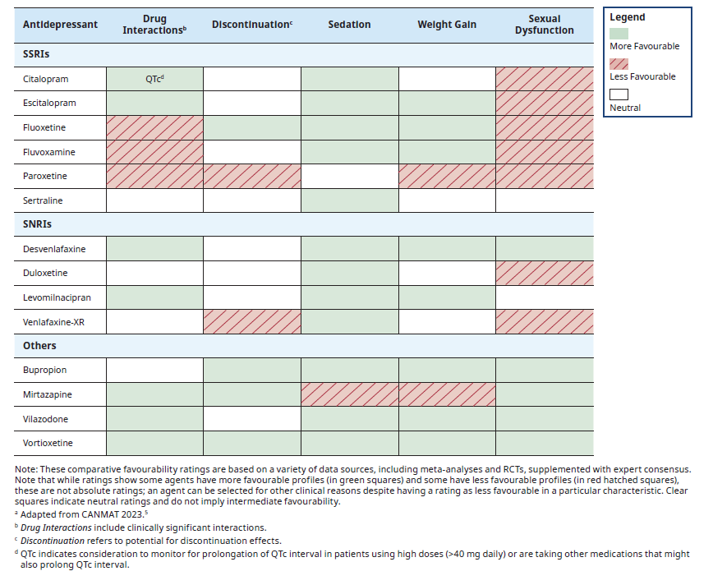
ª Adapted with permission from CANMAT Update on Clinical Guidelines for Management of Major Depressive Disorder in Adults et al. (2023).⁵

Figure 1. Approach to Diagnosis of MDD

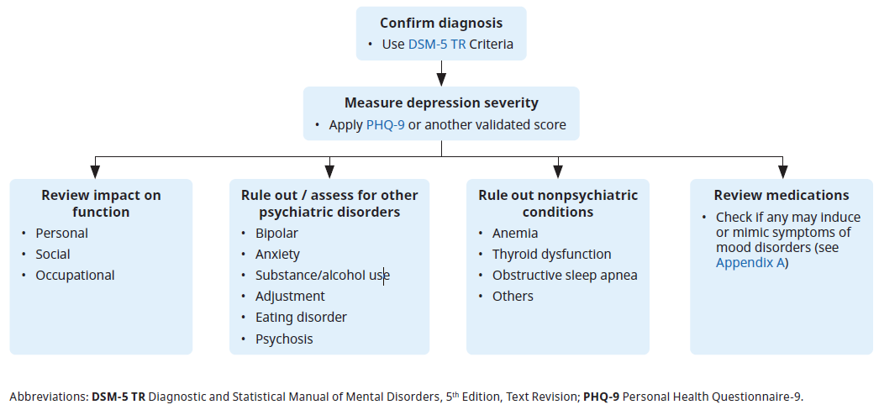
Figure 2. Acute Phase Treatment of MDD
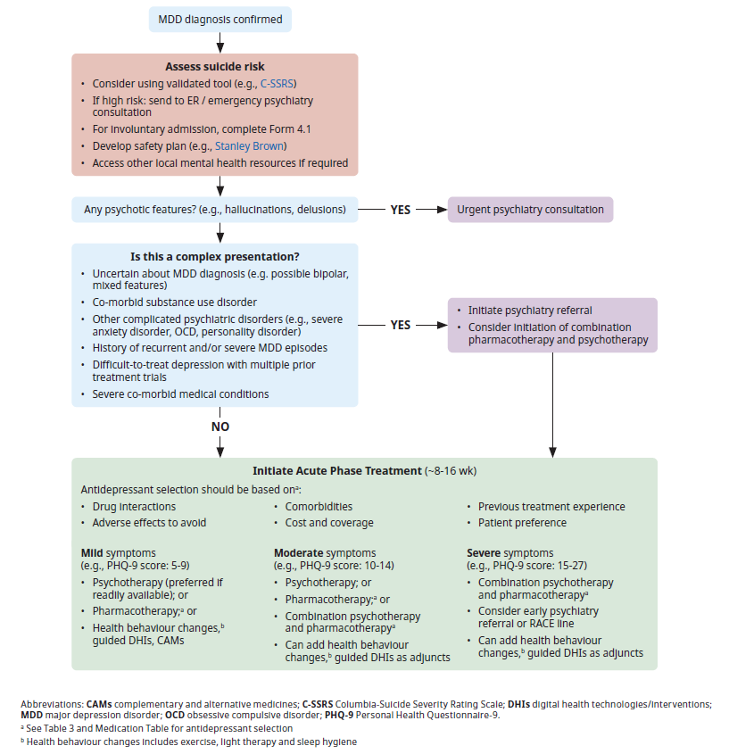
Figure 3. Assessing Treatment Response and Pharmacological Strategies

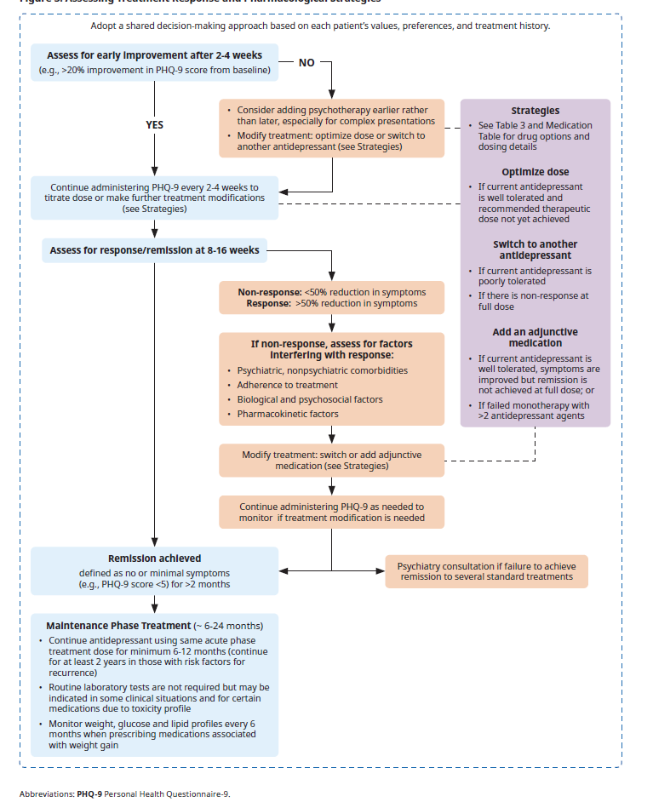

Figure 4. PHQ-9 Scores and depression severity
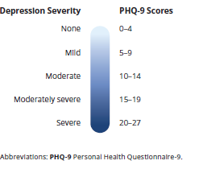
APPENDIX A: Common Medications That May Induce Mood Disorder Symptoms
Category | Mood Effects
Corticosteroids (e.g., prednisone, dexamethasone) | - Mood swings, mania, depression
Hormonal Agents (e.g., oral contraceptives, hormone therapy, anabolic steroids, tamoxifen, leuprolide) | - Depression, mood swings, anxiety
Beta-blockers (e.g., propranolol, metoprolol) | - Fatigue, depression, emotional blunting
Calcium channel blockers (e.g., amlodipine, diltiazem) | - Depression, asthenia, drowsiness
Anticonvulsants (e.g., levetiracetam, topiramate) | - Depression, irritability, suicidal ideation
Dopaminergic agents (e.g., levodopa, pramipexole) | - Mania, impulsivity, depression
Interferons (e.g., interferon-alpha) | - Depression, anxiety, irritability
Antiretrovirals (e.g., efavirenz) | - Depression, anxiety, suicidal ideation
Triptans (e.g., sumatriptan, rizatriptan) | - Depression, sedation, asthenia
Stimulants (e.g., amphetamines, methylphenidate) | - Anxiety, irritability, mood crashes
Isotretinoin (e.g., Accutane®, Epuris®) | - Depression, suicidal ideation
Alcohol and other drugs (e.g., cannabis, cocaine, MDMA) | - Depression, anxiety, mood instability during withdrawal or chronic use
Benzodiazepines and barbiturates (e.g., diazepam, lorazepam, phenobarbital) | - Emotional blunting, fatigue, depression, mood instability during withdrawal

Abbreviations: MDMA 3,4-methylenedioxymethamphetamine (commonly known as ecstasy)
References:
- American Psychiatric Association. (2013). Diagnostic and statistical manual of mental disorders (5th ed.). https://doi.org/10.1176/appi.books.9780890425596 [Accessed June 6, 2025].
- Gray Jean, editor. e-Therapeutics+ [Internet]. Ottawa (ON): Canadian Pharmacists Association; [Accessed June 6, 2025].
- Jobson MD. UpToDate [Internet]. Waltham, MA: UpToDate Inc.; [Accessed June 6, 2025].
- Health Canada Drug Product Database Product Monographs. Ottawa, ON: Health Canada; [Accessed June 6, 2025].
- Regier L, Jensen B, Crawley A, Soubolsky A. Depression: Overview of Major Depressive Disorder (MDD) & Treatment Resistant Depression. May 2025. Available from www.rxfiles.ca. [Accessed June 6, 2025].

Appendix b: Switching Antidepressants
Recommendations are for general guidance. Please consult a specialized reference (SwitchRx.ca) for instructions specific to a patient scenario.
Consider faster switches if adverse effects, no response to therapy, short duration of therapy (<6 weeks), or on low doses.
Switching From  Drug 1: | Switching To  Drug 2: | Recommended Switch Method​ª
Most antidepressants (Not an MAOI or fluoxetine) | Most antidepressants (Not an MAOI or fluoxetine) | - A cross-taper technique over 1 to 4 weeks can be applied whereby the dose of the first agent is tapered while the dose of the new antidepressant is gradually increased.  - For specific cross-tapering instructions, consult specialized resources such as SwitchRx.ca.  - Exceptions: Clomipramine is not recommended in cross-tapers; other exceptions are listed below.
Fluoxetine | Irreversible MAOI or moclobemide | - Slowly taper Drug 1 over 1-4 weeks until stopped.  - Wait for a washout period of 5-6 weeks before starting Drug 2
Fluoxetine | Any other antidepressant | - Use caution after fluoxetine discontinuation due to its long half-life. A washout period is often recommended, depending on the new agent.
Most antidepressants | Irreversible MAOI or moclobemide | - Slowly taper Drug 1 over 1-4 weeks until stopped.  - Wait 5 half-lives of first antidepressant (usually 1-3 weeks) before starting Drug 2.
Irreversible MAOI | Most antidepressants | - Slowly taper Drug 1 over 1-4 weeks until stopped.  - Wait for a washout period of 2-3 weeks before starting Drug 2
Moclobemide | Most antidepressants | - Slowly taper Drug 1 over 1-4 weeks until stopped.  - Wait for a washout period of 5 days before starting Drug 2
ªhttps://hub-pharmacists-ca.ezproxy.hlth.gov.bc.ca/home

