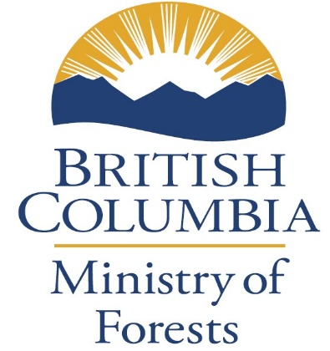 | SMALL SCALE SALVAGE PROGRAM  Haida Gwaii  Natural Resource District  Expression of Interest (EOI)
UPDATED: January 2026
Date submitted: Date received by HGNRD:

Name of applicant:

Address and Email:

Phone number:

Site Location Information (provide accurate road access and hauling route to the site from nearest town):

Type of Salvage being applied for (check)

Post Harvest Logging Residue

Damaged timber

Volume and Species Estimate

SX: m3
Cw: m3
Hw: m3
PL: m3

Total: m3

In addition to a complete and accurate EOI form please attach the following:

- Clear and accurate map (1:5000 for Damaged Timber and 1:10,000 for Post harvest)
- Overview photos showing the area of interest

