2025 Public Sector Organization
Climate Change Accountability Report (PSO CCAR)

- Timelines, Instructions & Template -

This document provides guidance to provincial public sector organizations (PSOs) in preparing their 2025 Climate Change Accountability Report (PSO CCAR) in accordance with the Climate Change Accountability Act (CCAA), section 8.1 and the Carbon Neutral Government Regulation (CNGR).
The information submitted through this reporting process also supports continued work to advance climate leadership in B.C.’s public sector.
This guidance document includes three sections:
- Timelines for the 2025 Reporting Year;
- Instructions for completing the 2025 PSO CCAR; and
- Template for the 2025 PSO CCAR.

Questions?
Please contact the Clean Government team at the Climate Action Secretariat (CAS) by emailing us at Carbon.Neutral@gov.bc.ca.

For Reference – Carbon Neutral Government (CNG) webpages
- Carbon Neutral Government program - CNG program timelines, requirements, guidance and templates
- Public sector Climate Change Accountability Reports - Highlights from the 2024 reporting year and link to all PSO CCARs from past years. This can be a useful resource to research other PSOs’ efforts to help advance your sector-specific plans and actions.

Timelines For The 2025 Reporting Year
The following timelines are applicable to all PSOs under the CNG program.
Due Date | Description
April 30, 2026 | - PSOs must enter all of their 2025 consumption data in the Clean Government Reporting Tool (CGRT).  - PSOs must complete the Self-Certification Checklist questionnaire in CGRT.  - CGRT closes to data entry.
Mid-to-late  May 2026 | - PSOs receive their 2025 offset invoice from CAS with the number of offsets required and amount to be paid.
May 31, 2026 | - PSOs must submit their signed PSO CCAR by email to Carbon.Neutral@gov.bc.ca.  - PSOs complete and submit the Public Sector Climate Leadership Survey (PSCL Survey) through SimpleSurvey; link included with the reporting year instructions emailed in January 2026. Completion of the survey is voluntary.
June 30, 2026 | - The Ministry of Energy and Climate Solutions must:  - Post all PSO CCARs on the Carbon Neutral Government website; and  - Retire sufficient carbon offsets on behalf of PSOs to achieve public sector carbon neutrality for the 2025 reporting year.  - PSOs must complete payment on their 2025 offset invoice and provide confirmation of payment by email to Carbon.Neutral@gov.bc.ca.

*Small Emitters: PSOs that reported less than 600 tonnes carbon dioxide equivalent (CO₂e) during the 2024 reporting year received a confirmation email from Carbon.Neutral@gov.bc.ca on December 3, 2025, confirming their status as a Small Emitter for the 2025 reporting year.
Small Emitters are required to follow the timelines and legislated reporting requirements as outlined above, but may use simplified reporting options:
- PSO CCAR template: Small Emitters must complete Part 1 Legislative Reporting Requirements and the Executive Signature section of the template. Completing other sections is optional but encouraged.
- PSCL Survey: Participation in the survey is voluntary and Small Emitters may choose whether to respond to questions identified as “Optional for Small Emitters”.

Instructions For Completing the PSO CCAR

Context
The CCAA and CNGR require that all PSOs prepare and make public an annual CCAR, documenting their organization’s emissions and offsets, the actions they have taken to reduce emissions, and their plans to reduce future emissions.
The PSO CCAR template below sets out the required content to:
- Achieve the legislated requirements; and
- Support public sector climate leadership.

Report Content - Minimum Report Requirements
The PSO CCAR must include the following minimum components as set out in the template:
  - Title
  - Organization name
  - Legislative Reporting Requirements:
    - Declaration Statement
    - Actions taken to minimize emissions
    - Plans to continue reducing emissions
    - Emissions and Offsets Summary Table
    - Retirement of Offsets Statement
  - Signature by a senior official such as CEO, COO or Superintendent

Report Format
The PSO CCAR should be written for a public audience. PSOs have full ownership over the look and formatting of the PSO CCAR, as well as any additional information they wish to include. Examples of optional elements include a cover page, photos, graphics and use of the Carbon Neutral logo (available for download).

Report Submission – Deadline: May 31, 2026
PSOs are required to submit their signed PSO CCAR by email to Carbon.Neutral@gov.bc.ca by May 31, 2026.
CAS will post all PSO CCARs to the BC Government’s CNG website by June 30, 2026. PSOs are encouraged to post their CCAR on their own website by the same date.

PSO CCAR Template
[Below is the 2025 PSO CCAR template. All text highlighted in grey provides instruction or guidance, and should be deleted or replaced with information specific to your organization.

PSOs may customize the look and formatting of their report, provided it includes the Minimum Report Requirements noted above.]

[Organization Name]
2025 Climate Change Accountability Report

Title: [Do not edit] 2025 Climate Change Accountability Report
Organization: [Organization Name]
PART 1. Legislative Reporting Requirements
[Information provided in this section will complete PSOs’ legislative reporting requirements under the Climate Change Accountability Act (section 8.1) and the Carbon Neutral Government (CNG) Regulation. Part 1 must be completed in full by all PSOs, including Small Emitters.]
Declaration statement: This PSO Climate Change Accountability Report for the period January 1, 2025 to December 31, 2025 summarizes our greenhouse gas (GHG) emissions profile, the total offsets to reach net-zero emissions, the actions we have taken in 2025 to minimize our GHG emissions, and our plans to continue reducing emissions in 2026 and beyond.
Emission Reductions: Actions & Plans
[Please describe the actions taken by your organization in the 2025 calendar year to minimize emissions and your plans to continue reducing emissions in future years. Refer to the guiding questions below, as applicable, for each emissions source category.]
- Stationary Sources (e.g., buildings, power generation)
[Please describe actions taken by your organization in 2025 to minimize emissions from stationary sources in buildings your organization owns or directly leases (see scope guidance) and plans to continue reducing those emissions in 2026 and beyond. Please provide details about goals, targets and progress related to GHG emissions reductions.
Consider the following guiding questions:

- Has your organization adopted any emissions reduction targets? If so, is your organization on track to achieve them?
- How did you consider emissions reductions in retrofits planned for, or carried out, in 2025?
- Whether you have a formal strategy or not, what are your organization’s specific plans to continue reducing emissions from stationary sources going forward?]

- Mobile Sources (e.g., fleet vehicles, off-road/portable equipment)
[Please describe actions taken by your organization in 2025 to minimize emissions from mobile sources and plans to continue reducing those emissions in 2026 and beyond.

Please include the following information:

- Indicate whether your organization acquired zero emission vehicles2 (ZEVs) or installed electric vehicle charging stations (EVCS) in 2025, including the number of ZEVs acquired and EVCS installed during the 2025 calendar year.
- Indicate whether your organization has any strategies or policies to reduce emissions from mobile sources, such as a Clean Fleet Plan3 or ZEV-First Purchasing Policy4.
  - If your organization has a Clean Fleet Plan or a ZEV-First Purchasing Policy, please provide a high-level summary and provide copy of it to the Clean Government team at CAS through your 2025 PSCL Survey or otherwise.

Consider these additional guiding questions:

- Did your organization develop and/or implement strategies to reduce fuel consumption (e.g., fleet optimization) or transition to a low-carbon fuel in 2025?
- What other related actions did your organization take in 2025 (e.g., charging station feasibility studies, electrical panel upgrades, guidance/training for fleet operators etc.)?
- Does your organization have any strategies to reduce emissions from air transportation, marine transportation, or off-road emission sources, as applicable?]

- Paper Consumption
[Please describe actions taken by your organization in 2025 to reduce emissions from paper and plans to continue reducing those emissions in 2026 and beyond.

Consider the following guiding questions:
- Does your organization have policies or guidelines in place for:
        - Reducing paper use (e.g., digital transformation to paperless business processes, established procedures for efficient, waste-free paper use, paper consumption awareness campaign, etc.); and/or
        - Purchasing environmentally and socially sustainable paper products (e.g., paper with recycled content, certified by the Forest Stewardship Council (FSC), etc.)?
- How does your organization plan to continue reducing emissions from paper use?]

- Fugitive Sources5 (e.g., heat pumps, refrigerators, air conditioners)
[Please describe actions taken by your organization in 2025 to reduce fugitive emissions from equipment your organization directly owns or leases (see scope guidance) and plans to continue reducing those emissions in 2026 and beyond.

Consider the following guiding questions:

- How is your organization tracking refrigeration equipment performance or monitoring refrigerant leaks (e.g., inventory systems, maintenance protocols, leak detection technologies)?
  - Has your organization installed any equipment that uses low global warming potential (GWP) refrigerants? Does your organization have any policies or guidelines to prioritize low-emission cooling systems or low-GWP refrigerants in future purchases or upgrades?]

2025 GHG Emissions and Offsets Summary Table
[Please see Appendix 1 for instructions on populating this table with your organization’s completed “CCAR 2025” report from CGRT. The table separates biogenic emissions (BioCO₂) from total emissions, as per international emission reporting protocols. Tip: To easily view the instructions, open Appendix 1 of this document in a new window on a second screen.
[Organization Name] 2025 GHG Emissions and Offsets Summary
GHG emissions for the period January 1 - December 31, 2025

[See Appendix 1 for instructions on how to access your 2025 emissions data from CGRT. Cells A and B below are identified in Figure 1 of the appendix; cells C and D are identified in Figure 2 of the appendix.]

Total BioCO₂ | Cell A
Total Emissions (tCO₂e) | Cell B
Total Offsets (tCO₂e) | Cell C
Adjustments to Offset Required GHG Emissions Reported in Prior Years
Total Offsets Adjustment (tCO₂e) | Cell D
Grand Total Offsets for the 2025 Reporting Year
Grand Total Offsets to be Retired for 2025 Reporting Year (tCO₂e) [must round to a whole number (no decimal places)] | Cell C + Cell D
Offset Investment ($)  [Grand Total Offsets to be Retired for 2025 Reporting Year x $25 per tCO₂e] | (Cell C + Cell D) x $25
- [Note, BioCO₂ is included in Total Emissions but not Total Offsets. For K-12 and post-secondary organizations, and BC Transit, Total Offsets might not equal Total Emissions minus Total BioCO₂ because offset exempt emissions for buses are included within Total Emissions.
- Emissions and offset investment amounts will be validated by CAS prior to distributing invoices.
- You must round “Grand Total Offsets to be Retired” to a whole number (no decimal places) before multiplying by $25 (e.g., 43.2 is rounded to 43, while 43.5 is rounded 44).]

Retirement of Offsets:
In accordance with the requirements of the Climate Change Accountability Act and the Carbon Neutral Government Regulation, [Organization Name] (the Organization) is responsible for arranging for the retirement of the offsets obligation reported above for the 2025 calendar year, together with any adjustments reported for past calendar years (if applicable). The Organization hereby agrees that, in exchange for the Ministry of Energy and Climate Solutions (the Ministry) ensuring that these offsets are retired on the Organization’s behalf, the Organization will pay within 30 days, the associated invoice to be issued by the Ministry in an amount equal to $25 per tonne of offsets retired on its behalf plus GST.
PART 2. Public Sector Climate Leadership
[Information provided in this section is essential to support continued planning for emissions reduction and climate change adaptation initiatives across the public sector, as well as inform high-level reporting in the annual provincial Climate Change Accountability Report. Small Emitters are encouraged, but not required, to complete this section.]

2A. Climate Risk Management
[Please describe actions taken by your organization in 2025 to manage risk related to the changing climate and plans to continue managing those risks in 2026 and beyond. For example, has your organization:
- Conducted a climate risk assessment to understand your organization’s risk exposure and vulnerability to identified risks? If not, do you plan to conduct an assessment next year or in future years?
- Made changes to operational procedures in response to current impacts driven by climate change, such as heat wave, drought, wildfire or flood?
- Made changes to the way services or programs are delivered to accommodate clients, partners, staff or other collaborators who are affected by a climate-related impact?
- Made any operational procedures or infrastructure changes in preparation for future climate impacts?
- Used climate data, analysis tools, and resources to inform your climate adaptation and greenhouse gas emission reduction efforts? Please provide references, if available.
- Incurred extra expenses in the last year in the form of staff overtime, hired subcontractors, or acquired equipment to manage climate risk and adapt to climate change?
- Taken any other measures to manage climate risk and adapt to the changing climate?]

2B. Additional Sustainability Initiatives
[Please describe any additional initiatives in your organization that support sustainability in general. For example, does your organization have any of the following:
- A low-carbon business travel policy or travel reduction goal? (low carbon = lowest emissions per kilometre traveled per passenger)
- An operations policy or program to facilitate the reduction and diversion of building occupant waste from landfills or incineration facilities? (e.g. composting, collection of plastics, battery recycling, etc.)
- Green procurement standards/policy for goods (e.g. office furniture, fleet, etc.)?
- A green lease6 strategy, or green lease clauses embedded in leasing documents?
- Water conservation measures in place?
- Climate engagement, education and awareness opportunities for staff and/or clients?
- Policies or guidelines for how climate change is factored into your organization's service delivery and decision-making?]

2C. Success Stories
[Please describe any success stories that your organization would like to highlight, whether related to reducing emissions or preparing for/adapting to a changing climate. For example, of all the emission reduction projects your organization undertook in 2025, is there one action that resulted in, or is expected to result in, the greatest emissions reductions? Consider including an estimate of the expected emission reductions from that project (in tonnes CO₂e and/or percentage reduction) as well as other benefits (e.g. cost savings) or key lessons learned.]
Executive Sign-off:
[All PSOs, including Small Emitters, must have their final report signed by a senior official, such as CEO, COO or Superintendent]

Signature | Date
Name (please print) | Title
[Please email your signed report to Carbon.Neutral@gov.bc.ca by no later than May 31, 2026.]

Appendix 1

Below are instructions to populate your organization’s 2025 GHG Emissions and Offsets Summary table in the PSO CCAR template above.

- Access the Clean Government Reporting Tool (CGRT) at https://gov-bc.mythinkstep.com/login. Note, you must be a registered Site Administrator or Data Collector for your organization. For assistance, contact Carbon.Neutral@gov.bc.ca.

- Once logged in, follow these steps:

1 |  | Click on the ‘Analytics’ tab and select ‘Intelligence Center’ from the drop-down menu.
2 |  | Within the Intelligence Center, search for, then click on, the report titled “1-CCAR 2025 report”.
3 |  | In the top right corner of the window, click the icon containing three horizontal dots to expand the options.
4 |  | Click the computer monitor icon to view the report (Show). The report will open in a new window.
5 |  | Click the icon containing two circular arrows at the top left of the window to “refresh” the report.  - This generates key analytics (see Figures 1 & 2 below for examples) used to populate your 2025 GHG Emissions and Offsets Summary table.  Note: Large analytics may take time to process, appearing in the job tray when complete. If you log out of CGRT before it finishes, the report will be emailed to you automatically when it is ready.
Optional |  | Optional: To save a copy of your “CCAR 2025 report”, click the download button (top right) to export it to Excel. You can do this any time, even while the analytics are calculating.

- Use the results of your “CCAR 2025 report” to populate your 2025 GHG Emissions and Offsets Summary table by referring to the cells identified in Figures 1 and 2 below. Obtain the values for cells A through D through your “CCAR 2025 report”.

- Lastly, complete the Offset Investment ($25 per tCO2e) line of the table by manually multiplying your Grand Total Offsets to be Retired for 2025 Reporting Year (tCO₂e) by $25. You must round your “Grand Total Offsets to be Retired” to a whole number (i.e. no decimal places) before multiplying by $25 (e.g., 43.2 is rounded to 43, while 43.5 is rounded 44).

- Your 2025 GHG Emissions and Offsets Summary table is now complete. Proceed with completing the remaining sections of your 2025 PSO CCAR, including executive sign-off, and submit your final CCAR to carbon.neutral@gov.bc.ca by May 31, 2026.

Figure 1. CCAR 2025 report (part 1)
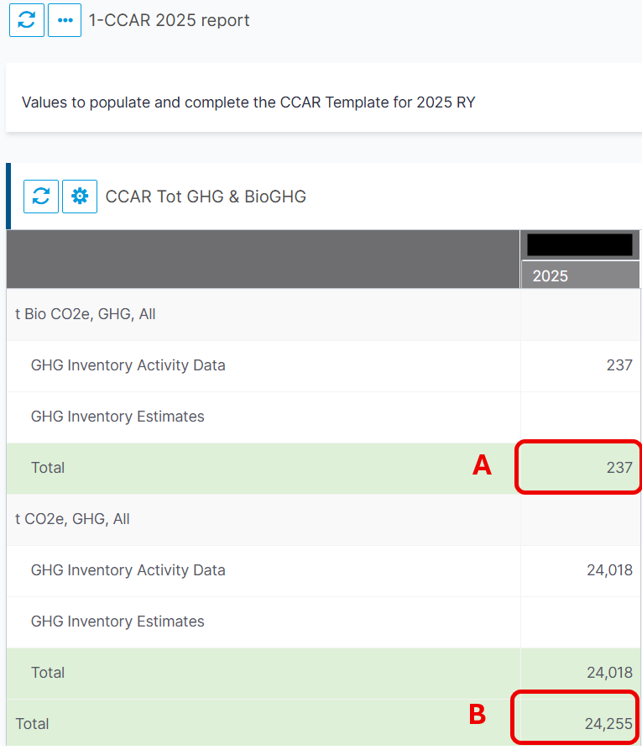
Note: In some cases, to view the values correctly, you may need to drag the vertical divider () to the left in the table header (grey background and with the year on the right).

Figure 2. CCAR 2025 report (part 2)
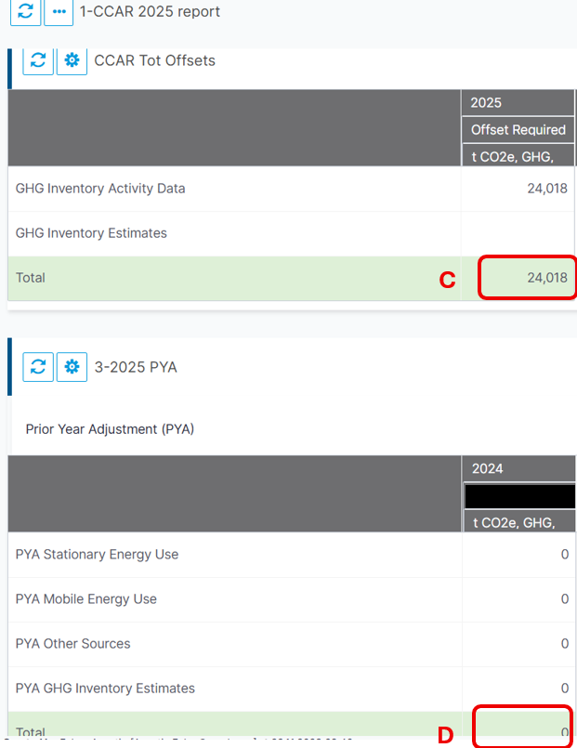
Note: In some cases, to view the values correctly, you may need to drag the vertical divider in the table header to the left (grey background and with the year on the right).

Retrofitting (nrcan.gc.ca)
2 Under the Zero-Emission Vehicles Regulation, zero-emission vehicles include battery electric vehicle (BEV), extended range electric vehicle (EREV), fuel cell electric vehicle (FCEV), and plug-in hybrid electric vehicle (PHEV).
3 Clean Fleet Plan: A multi-year plan that outlines how organizations will transition their light-duty vehicle fleets to zero-emission options, align charging and refueling infrastructure deployment, and reduce their greenhouse gas emissions related to fleet vehicles through other actions.
4 ZEV-First Purchasing Policy: A mechanism used to prioritize ZEVs as the default option when organizations purchase fleet vehicles (or off-road/portable equipment) where a suitable zero-emission option is available that meets operational requirements.
5 Fugitive sources: sources of greenhouse gas emissions resulting from unintentional releases (leaks) of gases, such as hydrofluorocarbon (HFC) refrigerants from equipment
6 Green leases align financial and sustainability objectives between a landlord and tenant and can include clauses for energy efficiency, water and waste management, as examples, that help to meet organizations’ related goals

