2026 ATTENDANCE RECORD
Employee Name & #: |  |  |  |  |  |  |  |  |  |  |  |  |  |  | Manager/Supervisor
Ministry/Branch/Section |  |  |  |  |  |  |  |  |  |  |  |  |  |  | Average Annual Work Unit STIIP/ESA for 2025
Colour Absence Codes: EDO – Earned Day Off (Flex)  A – STIIP and ESA V – Vacation/Annual Leave |  |  |  |  |  |  |  |  |  |  |  |  |  |  | O – Other Leave/LWOP M – Medical Appt  SP – Special or Supp Leave SH – Statutory Holidays
JANUARY |  |  |  |  |  |  |  | FEBRUARY |  |  |  |  |  |  |  | MARCH |  |  |  |  |  |  |  | APRIL
S | M | T | W | T | F | S |  | S | M | T | W | T | F | S |  | S | M | T | W | T | F | S |  | S | M | T | W | T | F | S
 |  |  |  | 1 | 2 | 3 |  | 1 | 2 | 3 | 4 | 5 | 6 | 7 |  | 1 | 2 | 3 | 4 | 5 | 6 | 7 |  |  |  |  | 1 | 2 | 3 | 4
4 | 5 | 6 | 7 | 8 | 9 | 10 |  | 8 | 9 | 10 | 11 | 12 | 13 | 14 |  | 8 | 9 | 10 | 11 | 12 | 13 | 14 |  | 5 | 6 | 7 | 8 | 9 | 10 | 11
11 | 12 | 13 | 14 | 15 | 16 | 17 |  | 15 | 16 | 17 | 18 | 19 | 20 | 21 |  | 15 | 16 | 17 | 18 | 19 | 20 | 21 |  | 12 | 13 | 14 | 15 | 16 | 17 | 18
18 | 19 | 20 | 21 | 22 | 23 | 24 |  | 22 | 23 | 24 | 25 | 26 | 27 | 28 |  | 22 | 23 | 24 | 25 | 26 | 27 | 28 |  | 19 | 20 | 21 | 22 | 23 | 24 | 25
25 | 26 | 27 | 28 | 29 | 30 | 31 |  |  |  |  |  |  |  |  |  | 29 | 30 | 31 |  |  |  |  |  | 26 | 27 | 28 | 29 | 30
Reasons |  |  |  |  |  |  |  | Reasons |  |  |  |  |  |  |  | Reasons |  |  |  |  |  |  |  | Reasons
MAY |  |  |  |  |  |  |  | JUNE |  |  |  |  |  |  |  | JULY |  |  |  |  |  |  |  | AUGUST
S | M | T | W | T | F | S |  | S | M | T | W | T | F | S |  | S | M | T | W | T | F | S |  | S | M | T | W | T | F | S
 |  |  |  |  | 1 | 2 |  |  | 1 | 2 | 3 | 4 | 5 | 6 |  |  |  |  | 1 | 2 | 3 | 4 |  |  |  |  |  |  |  | 1
3 | 4 | 5 | 6 | 7 | 8 | 9 |  | 7 | 8 | 9 | 10 | 11 | 12 | 13 |  | 5 | 6 | 7 | 8 | 9 | 10 | 11 |  | 2 | 3 | 4 | 5 | 6 | 7 | 8
10 | 11 | 12 | 13 | 14 | 15 | 16 |  | 14 | 15 | 16 | 17 | 18 | 19 | 20 |  | 12 | 13 | 14 | 15 | 16 | 17 | 18 |  | 9 | 10 | 11 | 12 | 13 | 14 | 15
17 | 18 | 19 | 20 | 21 | 22 | 23 |  | 21 | 22 | 23 | 24 | 25 | 26 | 27 |  | 19 | 20 | 21 | 22 | 23 | 24 | 25 |  | 16 | 17 | 18 | 19 | 20 | 21 | 22
24 | 25 | 26 | 27 | 28 | 29 | 30 |  | 28 | 29 | 30 |  |  |  |  |  | 26 | 27 | 28 | 29 | 30 | 31 |  |  | 23 | 24 | 25 | 26 | 27 | 28 | 29
31 |  |  |  |  |  |  |  |  |  |  |  |  |  |  |  |  |  |  |  |  |  |  |  | 30 | 31
Reasons |  |  |  |  |  |  |  | Reasons |  |  |  |  |  |  |  | Reasons |  |  |  |  |  |  |  | Reasons
SEPTEMBER |  |  |  |  |  |  |  | OCTOBER |  |  |  |  |  |  |  | NOVEMBER |  |  |  |  |  |  |  | DECEMBER
S | M | T | W | T | F | S |  | S | M | T | W | T | F | S |  | S | M | T | W | T | F | S |  | S | M | T | W | T | F | S
 |  | 1 | 2 | 3 | 4 | 5 |  |  |  |  |  | 1 | 2 | 3 |  | 1 | 2 | 3 | 4 | 5 | 6 | 7 |  |  |  | 1 | 2 | 3 | 4 | 5
6 | 7 | 8 | 9 | 10 | 11 | 12 |  | 4 | 5 | 6 | 7 | 8 | 9 | 10 |  | 8 | 9 | 10 | 11 | 12 | 13 | 14 |  | 6 | 7 | 8 | 9 | 10 | 11 | 12
13 | 14 | 15 | 16 | 17 | 18 | 19 |  | 11 | 12 | 13 | 14 | 15 | 16 | 17 |  | 15 | 16 | 17 | 18 | 19 | 20 | 21 |  | 13 | 14 | 15 | 16 | 17 | 18 | 19
20 | 21 | 22 | 23 | 24 | 25 | 26 |  | 18 | 19 | 20 | 21 | 22 | 23 | 24 |  | 22 | 23 | 24 | 25 | 26 | 27 | 28 |  | 20 | 21 | 22 | 23 | 24 | 25 | 26
27 | 28 | 29 | 30 |  |  |  |  | 25 | 26 | 27 | 28 | 29 | 30 | 31 |  | 29 | 30 |  |  |  |  |  |  | 27 | 28 | 29 | 30 | 31
Reasons |  |  |  |  |  |  |  | Reasons |  |  |  |  |  |  |  | Reasons |  |  |  |  |  |  |  | Reasons
Total Days Absent By Month
Jan |  | Feb |  | March |  | April |  | May |  | June |  | July |  | Aug |  | Sept |  | Oct |  | Nov |  | Dec |  | JANUARY 2027
 |  |  |  |  |  |  |  |  |  |  |  |  |  |  |  |  |  |  |  |  |  |  |  | S | M | T | W | T | F | S
Record of Discussions with Employee |  |  |  |  |  |  |  |  |  |  |  |  |  |  |  |  |  |  |  |  |  |  |  |  |  |  |  |  | 1 | 2
 |  |  |  |  |  |  |  |  |  |  |  |  |  |  |  |  |  |  |  |  |  |  |  | 3 | 4 | 5 | 6 | 7 | 8 | 9
 |  |  |  |  |  |  |  |  |  |  |  |  |  |  |  |  |  |  |  |  |  |  |  | 10 | 11 | 12 | 13 | 14 | 15 | 16
 |  |  |  |  |  |  |  |  |  |  |  |  |  |  |  |  |  |  |  |  |  |  |  | 17 | 18 | 19 | 20 | 21 | 22 | 23
 |  |  |  |  |  |  |  |  |  |  |  |  |  |  |  |  |  |  |  |  |  |  |  | 24 | 25 | 26 | 27 | 28 | 29 | 30

Attendance Calendar
The Attendance Calendar can be used to track the various absences from work and the reasons given by an employee. Near or above work unit average absences or a pattern indicates a consultation through AskMyHR. Failure to report to work as scheduled requires a supervisor to follow emergency contact process. More than one occasion of unexpected lateness indicates a consultation through AskMyHR.

To fill in colour in the date boxes on the calendar
- click on the specific date
- Select the colour fill-in icon  choose the corresponding detail absence colour
- click on the colour (from Standard Colors)

As noted in the sample below April 5, has been chosen as a STIIP day and highlighted in Red
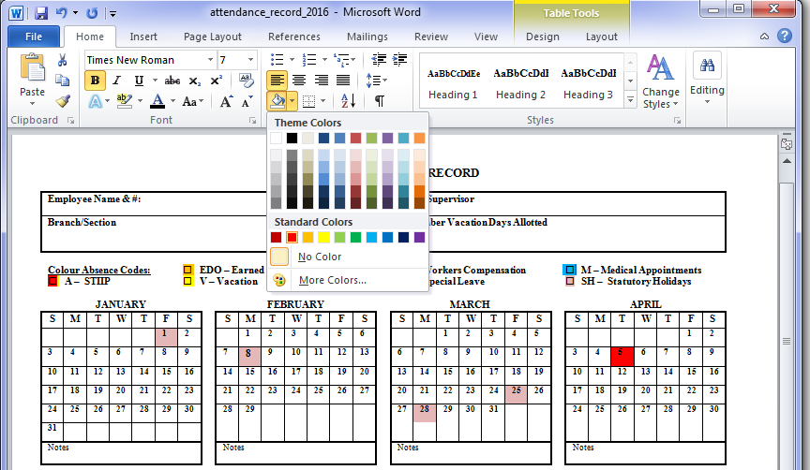
Each month there is a small text box for reasons given.
For consistency please use the following standard colours:
Red: any ESA or STIIP absence where the employee is using the ES or ST illness and injury benefit

Purple: Earned day off (EDO) from modified work week, flex time, CTO,ETO etc.

Yellow: Vacation entitlement

Gold: Other, to include LWOP (leave without pay), Workers Compensation, etc.

Green: Special Leave and Supplemental: Leaves identified in Main & component agreements

Blue: Medical Appointments under and over 2 hours
Rose: Statutory Holidays
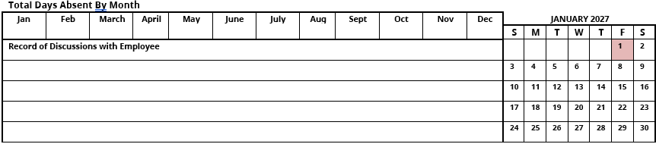
You can use this section to total the number of days absent per month, quarterly and list dates when attendance discussions took place with an employee.

