 |  | Ministry of Community Development and  Ministry of Tourism, Culture and the Arts
< System >
Technical Architecture
and Procedures

 |  | Date: < Date >
 |  | Prepared By: < Author’s Name >
 |  | Project: < Project Name >
 |  | Harvest Package Name: < RFC_#### or DEF_#### or DOC Name>
 |  | Harvest Version: < Harvest Version # >
 |  | Contract: < Contract # if applicable >

Table of Contents

Revision History ii
Document Approval ii
1 Overview 1
1.1 Outline 1
1.2 Detailed Description 1
1.3 Purpose/Background/System Description 2
1.4 In Scope 2
1.5 Out of Scope 2
1.6 Assumptions/Constraints 2
2 Application Overview 3
3 User Community 3
3.1 Internal/External 3
3.2 Current Interaction 3
3.3 Hours of Operation 3
3.4 Technology in Place Today 3
3.5 Connectivity 3
4 Data Characteristics 3
4.1 Subject Matter 3
4.2 Data Sensitivity 4
4.3 Data Flows 4
4.4 Volumes and Frequencies 4
4.5 Existing Data 4
4.6 Data Volatility 4
5 Interaction Characteristics 5
5.1 Client Interaction 5
5.2 Application Interaction 5
5.3 Interface Run Dependencies 5
5.4 Foreign System Unavailability Implications 6
5.5 Interface Integrity Constraints 6
6 System Architecture 6
6.1 Architecture Overview 7
6.2 Hardware Components 8
6.3 Software Components 9
6.4 Security 9
7 Other Architectural Features Related to non-functional requirements 9
Appendix A 10
Appendix B 11

Revision History

{ Use the following table to list amendments and additions to the document. }

Date | Harvest Version | Section | Description | Author
<dd/mmm/yy> | <xx> | <section> | <details> | <name>

Document Approval

{ If applicable, obtain approval prior to publishing document. }

This document has been approved by:

Signature |  | Date
Fredo Vanlierop |  | Technical Architect
Print Name |  | Title

[PLEASE REMOVE THE FOLLOWING “DOCUMENT FORMAT” INSTRUCTIONS IN YOUR RELEASE DOCUMENTATION]

Document Format
The (title) document should contain all of the sections contained in this (title) document template. DO NOT DELETE SECTIONS THAT DO NOT APPLY TO THE PRODUCT RELEASE BEING SPECIFIED, but rather indicate in the section that it was intentionally left blank. Leaving the section in the document rather than deleting it, reduces confusion for reviewers who may not be sure if the section was intentionally deleted or just omitted.

This template includes red text providing directions. This text should be removed from the actual document created using the template. The titles in this document also have red text to indicate where specific document titles need to be provided. These titles should be changed to black text in the actual document.

[Objectives of Template]
• [To make you think about the entire problem]
• [To focus on characteristics of problem that will shape a technical solution]
• [To enable a consistent peer review process]
• [To encourage consideration of preferable application design patterns]
• [To encourage the use of existing infrastructure]

The document is broken down into several chapters. After an application overview it describes the user community, data characteristics and interfaces before describing the chosen application architecture in detail.

Overview

Outline
Summary based on table of contents

Detailed Description

Provide a detailed overview of the entire document:

      - Describe the purpose and contents of this document rather than the purpose of the project (see 1.3).
      - Describe this document's intended audience
      - Identify the system/product using any applicable names and/or version numbers
      - Provide references and summarize any other pertinent documents such as:
        - Related and/or companion documents
        - Documents which provide background and/or context for this document
        - Documents that result from this document (e.g. test plan or a development plan)

Purpose/Background/System Description
The purpose of this document is to provide a common understanding of the technical architecture to be used during development and implementation by describing the target platforms and the software architecture.

In Scope
What is included in this documentation?

Out of Scope
List any exception to items that are not included in the scope and provide reasons for their exclusions.

Assumptions/Constraints
Indicate, and explain in detail, any assumptions or constraints that may affect the purpose of this document.

Application Overview
[Overview of the application]

User Community

Internal/External
[User Community]
• [Internal or external]
– [Citizens, Contractors, Businesses, etc]
– [Are there distinct groups? (e.g. Ministry is query/report, Contractor is data entry)]
– [How many of each group?]
– [Estimated number of uniquely identified users? Must they be authorized?]

Current Interaction
• [Do users interact with CS today or are they planned?]
– [e.g. STVDES, Ministry Services]
– [What applications? What infrastructure?]
• [Comfort level with technology]
– [use it today as part of day to day activity (yes, no, somewhat)]
– [does client have a HelpDesk already?]
– [Does the solution have to fit a lowest common denominator?]

Hours of Operation
• [Hours of Operation]
– [24 hours e.g. Business Critical]
– [9-5 standard business hours e.g. employers]
– [helpdesk services required?]

Technology in Place Today
• [Technology in place today]
– [PC workstations, no internet access, limited utilization of technology]
– [Will CS have to support widely varying user platforms?]

Connectivity
• [Network Connectivity and Bandwidth in place today]
– [dial-up only]
– [SPAN/BC / Connectivity Speed]
– [Internet access required? (not just SPAN/BC)]

Data Characteristics

Subject Matter
• [What is the subject matter of the data?]

Data Sensitivity
• [Sensitivity of Data]
- [personal, aggregate anonymous, financial
- [data classification if available ]
- [perceived security requirements ]
- [CS Communications Involvement ]

Data Flows
• [Which are the data flows?]
- [What direction is primary data flow?]
• [To the Ministry or from the Ministry]
- [Eventually, will the data (or some aggregate) flow to a data warehouse?]

Volumes and Frequencies
- [Is there a peak period? (such as year-end when everyone submits)]
- [e.g. weekly uploads to CS with monthly downloads (upload consists of 2000 records)]

Existing Data
• [Does data exist today in electronic form?]
- [Sender]
• [Yes, in Patient Admin System]
• [No, is usually keyed]
• [What is the format? Is there an agreed upon format?]
• [Do the target clients all have different solutions/formats/etc. *]
• [Is the data submitted usually an update of previous period?]
- [Receiver]
• [Is the data submitted usually an update of previous period?]
• [Will there be a reporting facility back to the sender?]
• [Data access frequency requirements?]
– [Ministry (required daily, weekly, monthly, annual)]
- [Client (download once a month)]

Data Volatility
• [Estimate of data structure change volatility ]
- [low, medium, high]
- [short term & long term]
• [Estimate of volume change volatility]
- [low, medium, high]
- [provide estimate if possible]

Archive and Purge of old data
[Describe the data archive and purge parameters]
[Describe how the parameters are implemented in the system]

Interaction Characteristics

Client Interaction
• [Data entry edit sophistication?]
– [Yes, lots of cross field edits and calculated ranges]
– [Are the domain of values known?]
• [Synchronous interaction or Business Flow?]
– [Is the data entry task interruptible]
– [e.g. (Synchronous = Name Search or Update Address)]
• [Availability Requirements?]
– [Must be available all the time (unlikely)]
– [Is a back-up facility required if component breaks?]

Application Interaction
• [What interfaces to other products/applications exist
• [Will the user have to interact with other applications in order to supply data?]
• [What other applications must co-exist at the user’s desktop?]

Interface Run Dependencies
This table shows the sequence in which the various system interfaces must be run to ensure that <Application Name> will have consistent data. The foreign end of the interface is the other end to the new system.
Interface | Criticality | Dependencies | Foreign End System Requirements | Foreign End Dependencies
Table: System Interface Dependencies
Read the table using the following definitions:
Column Name | Definition
Interface | The name and a reference number for each interface.
Criticality | Low - the new system can be used with no loss of integrity.  Medium - The new system can be used with little loss integrity. The problem must be addressed within a week.  High - The integrity of the new system will be significantly violated. The problem must be addressed immediately.
Dependencies | The sequence of reference numbers of the interfaces that must be run before this one.
Foreign End System Requirements | The required status of the system from which the data is being loaded.
Foreign End Dependencies | Interfaces that must be run for the foreign end of the interface to be successful.
Table: Column definitions for Table: System Interface Run Dependencies

Foreign System Unavailability Implications
This table describes what happened when the foreign end of the interface becomes unavailable.
Interface | Action Required at Run-Time | Implications During System Usage | Catch Up Required
Table: Foreign System Unavailability Implications
Read the table using the following definitions:
Column Name | Definition
Interface | The name and a reference number for each interface.
Action Required at Run Time | What will need to be done when the job fails. (as well as alerting system support personnel).
Implications During System Usage | What affect the unavailability of the interface will have.
Catch Up Required | What will need to be done to bring the system up to date if the interface fails. This could mean manually typing in data.
Table: Definitions for Table: Foreign System Unavailability Implications

Interface Integrity Constraints
This component describes the business rules that apply to the foreign end of each interface.
Include valid values and referential integrity.
Interface | Business Rules
Table: Interface Integrity Constraints

System Architecture
[The following diagram shows the system architecture for <System>. An example of the a system architecture is included to show the level of detail required
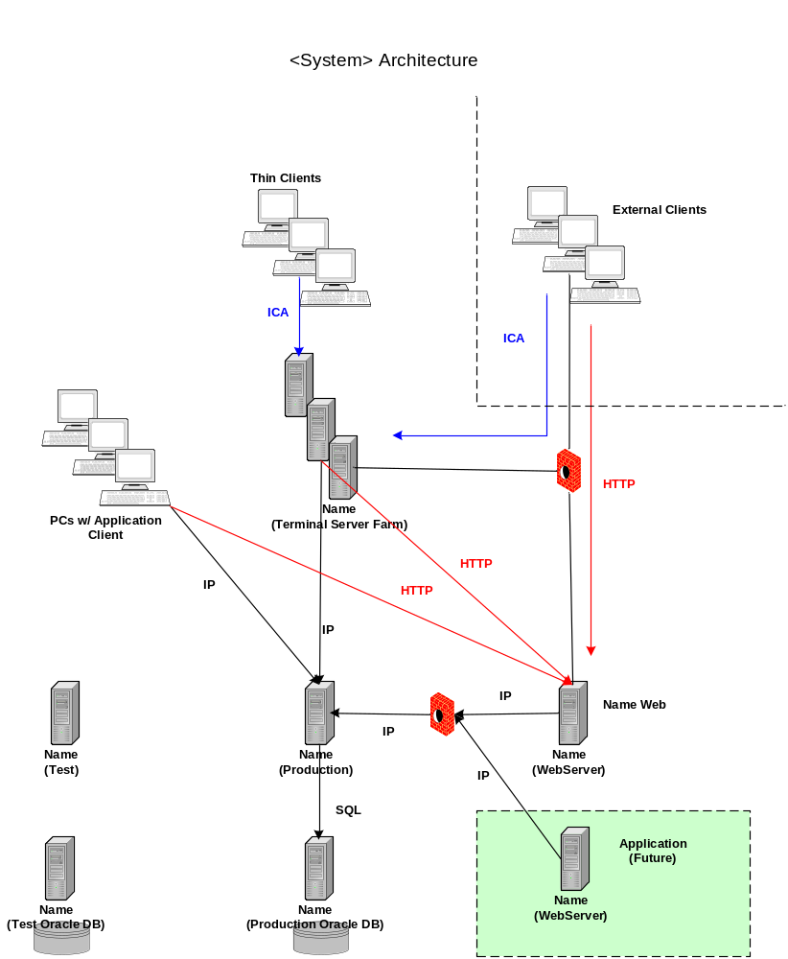

Architecture Overview
This section should provide a high-level overview of how the functionality and responsibilities of the system were partitioned and then assigned to subsystems or components. Don't go into too much detail about the individual components themselves, as these should be covered in later sections. The main purpose here is to gain a general understanding of how and why the system was decomposed, and how the individual parts work together to provide the desired functionality.

At the top-most level:
Describe the major responsibilities that the software must undertake (such as batch processes, messaging) and the various roles that the system (or portions of the system) must play.
Describe how the system was broken down into its components/subsystems (identifying each top-level component/subsystem and the roles/responsibilities assigned to it).
Include information on the database access/persistence mechanism of the product.
Describe how the higher-level components collaborate with each other in order to achieve the required results. Include interfaces to other products or common components.
Describe the system’s failover and clustering mechanisms
Provide a diagram of the major system components. An example of the Harvest architecture is shown below as an example of the level of architecture desired.
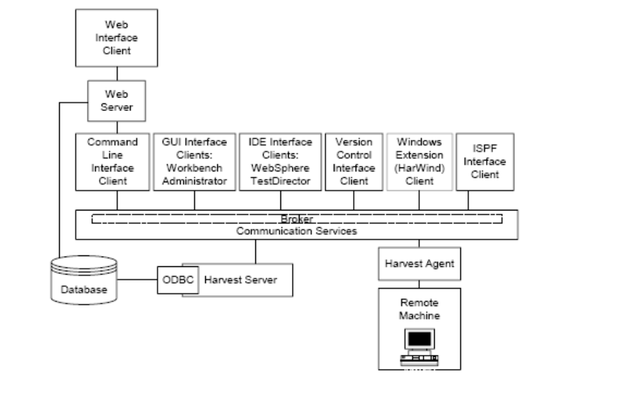

Hardware Components
[This section will describe each hardware component in detail.]
Hardware | Brand | Name | Remarks
MS Web Server | Compaq DL380 | Rook | Environment: Dev/Del/Test  RAM: 1 GB  CPU: 2x1.1GHz PIII
Environment:
RAM :
CPU:
Environment:
RAM:
CPU:

Software Components
[This section will describe each software component in detail.]

Security
[This section will describe each security aspect in detail.]

Other Architectural Features Related to non-functional requirements
[This section will describe any other aspects of the architecture designed to satisfy significant non-functional requirements. Use separate headings as required. You may refer to standard CS operational processes if they are sufficient to meet requirements. Exceptions to the standard processes must be documented
For example
Quality requirements
Service level requirements
Performance characteristics
Audit requirements
Error notification and reporting
Error recovery
Backup Processes

Appendices

Appendix A

{ Glossary }

Appendix B

{ Additional Appendix }

